**Developing restful web services in spring boot**

1. **Create Spring boot project with following dependencies:**

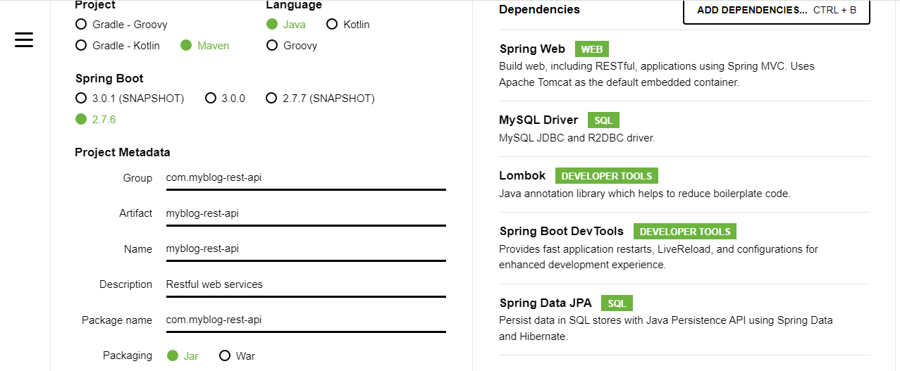

1. Create Following Project Structure in IntelliJ Idea

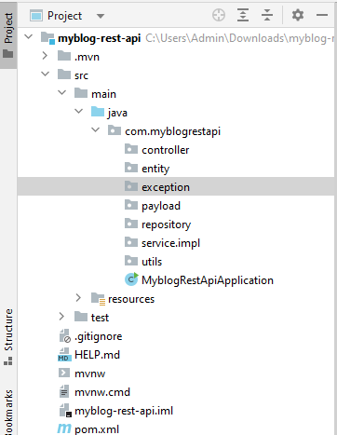

Step 3: Create POST Entity Class

import lombok.AllArgsConstructor;

import lombok.Data;

import lombok.NoArgsConstructor;

import javax.persistence.*;

@Data

@AllArgsConstructor

@NoArgsConstructor

@Entity

@Table

(

name = "posts", uniqueConstraints = {@UniqueConstraint(columnNames = {"title"})}

)

public class Post {

@Id

@GeneratedValue( strategy = GenerationType.IDENTITY) )

private Long id;

@Column(name = "title", nullable = false)

private String title;

@Column(name = "description", nullable = false)

private String description;

@Column(name = "content", nullable = false)

private String content;

}

Step 3: Update application.properties file

spring.datasource.url = jdbc:mysql://localhost:3306/myblog?useSSL=false&serverTimezone=UTC

spring.datasource.username = root

spring.datasource.password = root

# hibernate properties

spring.jpa.properties.hibernate.dialect = org.hibernate.dialect.MySQL5InnoDBDialect

# Hibernate ddl auto

spring.jpa.hibernate.ddl-auto = update

Step 4: Create Post Repository Layer:

import org.springframework.data.jpa.repository.JpaRepository;

public interface PostRepository extends JpaRepository<Post, Long> {

}

Step 5: Create Payload PostDto class

import lombok.Data;

@Data

public class PostDto {

private long id;

private String title;

private String description;

private String content;

}

Step 6: Create PostService Interface

import java.util.List;

public interface PostService {

PostDto createPost(PostDto postDto);

}

Step 7: Create PostServiceImpl class

@Service

public class PostServiceImpl implements PostService {

private PostRepository postRepository;

public PostServiceImpl(PostRepository postRepository) {

this.postRepository = postRepository;

}

@Override

public PostDto createPost(PostDto postDto) {

// convert DTO to entity

Post post = mapToEntity(postDto);

Post newPost = postRepository.save(post);

// convert entity to DTO

PostDto postResponse = mapToDTO(newPost);

return postResponse;

}

// convert Entity into DTO

private PostDto mapToDTO(Post post){

PostDto postDto = new PostDto();

postDto.setId(post.getId());

postDto.setTitle(post.getTitle());

postDto.setDescription(post.getDescription());

postDto.setContent(post.getContent());

return postDto;

}

// convert DTO to entity

private Post mapToEntity(PostDto postDto){

Post post = new Post();

post.setTitle(postDto.getTitle());

post.setDescription(postDto.getDescription());

post.setContent(postDto.getContent());

return post;

}

}

Step 8: Create PostController Class:

@RestController

@RequestMapping("/api/posts")

public class PostController {

private PostService postService;

public PostController(PostService postService) {

this.postService = postService;

}

// create blog post rest api

@PostMapping

public ResponseEntity<PostDto> createPost(@RequestBody PostDto postDto){

return new ResponseEntity<>(postService.createPost(postDto), HttpStatus.CREATED);

}

}

Step 9: Create Exception class

import org.springframework.http.HttpStatus;

import org.springframework.web.bind.annotation.ResponseStatus;

@ResponseStatus(value = HttpStatus.NOT_FOUND)

public class ResourceNotFoundException extends RuntimeException{

private String resourceName;

private String fieldName;

private long fieldValue;

public ResourceNotFoundException(String resourceName, String fieldName, long fieldValue) {

super(String.format("%s not found with %s : '%s'", resourceName, fieldName, fieldValue)); // Post not found with id : 1

this.resourceName = resourceName;

this.fieldName = fieldName;

this.fieldValue = fieldValue;

}

public String getResourceName() {

return resourceName;

}

public String getFieldName() {

return fieldName;

}

public long getFieldValue() {

return fieldValue;

}

}

Step 10: Create GetMapping in controller layer:

import java.util.List;

@RestController

@RequestMapping("/api/posts")

public class PostController {

private PostService postService;

public PostController(PostService postService) {

this.postService = postService;

}

// create blog post rest api

@PostMapping

public ResponseEntity<PostDto> createPost(@RequestBody PostDto postDto){

return new ResponseEntity<>(postService.createPost(postDto), HttpStatus.CREATED);

}

// get all posts rest api

@GetMapping

public List<PostDto> getAllPosts(){

return postService.getAllPosts();

}

}

Step 11: Update PostService interface:

import com.springboot.blog.payload.PostDto;

import java.util.List;

public interface PostService {

PostDto createPost(PostDto postDto);

List<PostDto> getAllPosts();

}

Step 12: Update PostServiceImpl class:

import com.springboot.blog.entity.Post;

import com.springboot.blog.exception.ResourceNotFoundException;

import com.springboot.blog.payload.PostDto;

import com.springboot.blog.repository.PostRepository;

import com.springboot.blog.service.PostService;

import org.springframework.beans.factory.annotation.Autowired;

import org.springframework.stereotype.Service;

import java.util.List;

import java.util.stream.Collectors;

@Service

public class PostServiceImpl implements PostService {

private PostRepository postRepository;

public PostServiceImpl(PostRepository postRepository) {

this.postRepository = postRepository;

}

@Override

public PostDto createPost(PostDto postDto) {

// convert DTO to entity

Post post = mapToEntity(postDto);

Post newPost = postRepository.save(post);

// convert entity to DTO

PostDto postResponse = mapToDTO(newPost);

return postResponse;

}

@Override

public List<PostDto> getAllPosts() {

List<Post> posts = postRepository.findAll();

return posts.stream().map(post -> mapToDTO(post)).collect(Collectors.toList());

}

// convert Entity into DTO

private PostDto mapToDTO(Post post){

PostDto postDto = new PostDto();

postDto.setId(post.getId());

postDto.setTitle(post.getTitle());

postDto.setDescription(post.getDescription());

postDto.setContent(post.getContent());

return postDto;

}

// convert DTO to entity

private Post mapToEntity(PostDto postDto){

Post post = new Post();

post.setTitle(postDto.getTitle());

post.setDescription(postDto.getDescription());

post.setContent(postDto.getContent());

return post;

}

}

Step 13: Create GetMapping By Id:

import com.springboot.blog.payload.PostDto;

import com.springboot.blog.service.PostService;

import org.springframework.http.HttpStatus;

import org.springframework.http.ResponseEntity;

import org.springframework.web.bind.annotation.*;

import java.util.List;

@RestController

@RequestMapping("/api/posts")

public class PostController {

private PostService postService;

public PostController(PostService postService) {

this.postService = postService;

}

// create blog post rest api

@PostMapping

public ResponseEntity<PostDto> createPost(@RequestBody PostDto postDto){

return new ResponseEntity<>(postService.createPost(postDto), HttpStatus.CREATED);

}

// get all posts rest api

@GetMapping

public List<PostDto> getAllPosts(){

return postService.getAllPosts();

}

// get post by id

@GetMapping("/{id}")

public ResponseEntity<PostDto> getPostById(@PathVariable(name = "id") long id){

return ResponseEntity.ok(postService.getPostById(id));

}

}

Step 14: Update PostServiceImpl interface:

import com.springboot.blog.payload.PostDto;

import java.util.List;

public interface PostService {

PostDto createPost(PostDto postDto);

List<PostDto> getAllPosts();

PostDto getPostById(long id);

}

Step 15: Update PostServiceImpl class

import com.springboot.blog.entity.Post;

import com.springboot.blog.exception.ResourceNotFoundException;

import com.springboot.blog.payload.PostDto;

import com.springboot.blog.repository.PostRepository;

import com.springboot.blog.service.PostService;

import org.springframework.beans.factory.annotation.Autowired;

import org.springframework.stereotype.Service;

import java.util.List;

import java.util.stream.Collectors;

@Service

public class PostServiceImpl implements PostService {

private PostRepository postRepository;

public PostServiceImpl(PostRepository postRepository) {

this.postRepository = postRepository;

}

@Override

public PostDto createPost(PostDto postDto) {

// convert DTO to entity

Post post = mapToEntity(postDto);

Post newPost = postRepository.save(post);

// convert entity to DTO

PostDto postResponse = mapToDTO(newPost);

return postResponse;

}

@Override

public List<PostDto> getAllPosts() {

List<Post> posts = postRepository.findAll();

return posts.stream().map(post -> mapToDTO(post)).collect(Collectors.toList());

}

@Override

public PostDto getPostById(long id) {

Post post = postRepository.findById(id).orElseThrow(() -> new ResourceNotFoundException("Post", "id", id));

return mapToDTO(post);

}

// convert Entity into DTO

private PostDto mapToDTO(Post post){

PostDto postDto = new PostDto();

postDto.setId(post.getId());

postDto.setTitle(post.getTitle());

postDto.setDescription(post.getDescription());

postDto.setContent(post.getContent());

return postDto;

}

// convert DTO to entity

private Post mapToEntity(PostDto postDto){

Post post = new Post();

post.setTitle(postDto.getTitle());

post.setDescription(postDto.getDescription());

post.setContent(postDto.getContent());

return post;

}

}

Step 16: Create UpdatePost Controller

import com.springboot.blog.payload.PostDto;

import com.springboot.blog.service.PostService;

import org.springframework.http.HttpStatus;

import org.springframework.http.ResponseEntity;

import org.springframework.web.bind.annotation.*;

import java.util.List;

@RestController

@RequestMapping("/api/posts")

public class PostController {

private PostService postService;

public PostController(PostService postService) {

this.postService = postService;

}

// create blog post rest api

@PostMapping

public ResponseEntity<PostDto> createPost(@RequestBody PostDto postDto){

return new ResponseEntity<>(postService.createPost(postDto), HttpStatus.CREATED);

}

// get all posts rest api

@GetMapping

public List<PostDto> getAllPosts(){

return postService.getAllPosts();

}

// get post by id

@GetMapping("/{id}")

public ResponseEntity<PostDto> getPostById(@PathVariable(name = "id") long id){

return ResponseEntity.ok(postService.getPostById(id));

}

// update post by id rest api

@PutMapping("/{id}")

public ResponseEntity<PostDto> updatePost(@RequestBody PostDto postDto, @PathVariable(name = "id") long id){

PostDto postResponse = postService.updatePost(postDto, id);

return new ResponseEntity<>(postResponse, HttpStatus.OK);

}

}

Step 17: Update PostService Interface:

import com.springboot.blog.payload.PostDto;

import java.util.List;

public interface PostService {

PostDto createPost(PostDto postDto);

List<PostDto> getAllPosts();

PostDto getPostById(long id);

PostDto updatePost(PostDto postDto, long id);

}

Step 18: Update PostServiceImpl class:

import com.springboot.blog.entity.Post;

import com.springboot.blog.exception.ResourceNotFoundException;

import com.springboot.blog.payload.PostDto;

import com.springboot.blog.repository.PostRepository;

import com.springboot.blog.service.PostService;

import org.springframework.beans.factory.annotation.Autowired;

import org.springframework.stereotype.Service;

import java.util.List;

import java.util.stream.Collectors;

@Service

public class PostServiceImpl implements PostService {

private PostRepository postRepository;

public PostServiceImpl(PostRepository postRepository) {

this.postRepository = postRepository;

}

@Override

public PostDto createPost(PostDto postDto) {

// convert DTO to entity

Post post = mapToEntity(postDto);

Post newPost = postRepository.save(post);

// convert entity to DTO

PostDto postResponse = mapToDTO(newPost);

return postResponse;

}

@Override

public List<PostDto> getAllPosts() {

List<Post> posts = postRepository.findAll();

return posts.stream().map(post -> mapToDTO(post)).collect(Collectors.toList());

}

@Override

public PostDto getPostById(long id) {

Post post = postRepository.findById(id).orElseThrow(() -> new ResourceNotFoundException("Post", "id", id));

return mapToDTO(post);

}

@Override

public PostDto updatePost(PostDto postDto, long id) {

// get post by id from the database

Post post = postRepository.findById(id).orElseThrow(() -> new ResourceNotFoundException("Post", "id", id));

post.setTitle(postDto.getTitle());

post.setDescription(postDto.getDescription());

post.setContent(postDto.getContent());

Post updatedPost = postRepository.save(post);

return mapToDTO(updatedPost);

}

// convert Entity into DTO

private PostDto mapToDTO(Post post){

PostDto postDto = new PostDto();

postDto.setId(post.getId());

postDto.setTitle(post.getTitle());

postDto.setDescription(post.getDescription());

postDto.setContent(post.getContent());

return postDto;

}

// convert DTO to entity

private Post mapToEntity(PostDto postDto){

Post post = new Post();

post.setTitle(postDto.getTitle());

post.setDescription(postDto.getDescription());

post.setContent(postDto.getContent());

return post;

}

}

Step 19: Create DeleteMapping controller:

import com.springboot.blog.payload.PostDto;

import com.springboot.blog.service.PostService;

import org.springframework.http.HttpStatus;

import org.springframework.http.ResponseEntity;

import org.springframework.web.bind.annotation.*;

import java.util.List;

@RestController

@RequestMapping("/api/posts")

public class PostController {

private PostService postService;

public PostController(PostService postService) {

this.postService = postService;

}

// create blog post rest api

@PostMapping

public ResponseEntity<PostDto> createPost(@RequestBody PostDto postDto){

return new ResponseEntity<>(postService.createPost(postDto), HttpStatus.CREATED);

}

// get all posts rest api

@GetMapping

public List<PostDto> getAllPosts(){

return postService.getAllPosts();

}

// get post by id

@GetMapping("/{id}")

public ResponseEntity<PostDto> getPostById(@PathVariable(name = "id") long id){

return ResponseEntity.ok(postService.getPostById(id));

}

// update post by id rest api

@PutMapping("/{id}")

public ResponseEntity<PostDto> updatePost(@RequestBody PostDto postDto, @PathVariable(name = "id") long id){

PostDto postResponse = postService.updatePost(postDto, id);

return new ResponseEntity<>(postResponse, HttpStatus.OK);

}

// delete post rest api

@DeleteMapping("/{id}")

public ResponseEntity<String> deletePost(@PathVariable(name = "id") long id){

postService.deletePostById(id);

return new ResponseEntity<>("Post entity deleted successfully.", HttpStatus.OK);

}

}

Step 20: Update PostService Interface:

import com.springboot.blog.payload.PostDto;

import java.util.List;

public interface PostService {

PostDto createPost(PostDto postDto);

List<PostDto> getAllPosts();

PostDto getPostById(long id);

PostDto updatePost(PostDto postDto, long id);

void deletePostById(long id);

}

Step 21: Create PostServiceImpl class:

import com.springboot.blog.entity.Post;

import com.springboot.blog.exception.ResourceNotFoundException;

import com.springboot.blog.payload.PostDto;

import com.springboot.blog.repository.PostRepository;

import com.springboot.blog.service.PostService;

import org.springframework.beans.factory.annotation.Autowired;

import org.springframework.stereotype.Service;

import java.util.List;

import java.util.stream.Collectors;

@Service

public class PostServiceImpl implements PostService {

private PostRepository postRepository;

public PostServiceImpl(PostRepository postRepository) {

this.postRepository = postRepository;

}

@Override

public PostDto createPost(PostDto postDto) {

// convert DTO to entity

Post post = mapToEntity(postDto);

Post newPost = postRepository.save(post);

// convert entity to DTO

PostDto postResponse = mapToDTO(newPost);

return postResponse;

}

@Override

public List<PostDto> getAllPosts() {

List<Post> posts = postRepository.findAll();

return posts.stream().map(post -> mapToDTO(post)).collect(Collectors.toList());

}

@Override

public PostDto getPostById(long id) {

Post post = postRepository.findById(id).orElseThrow(() -> new ResourceNotFoundException("Post", "id", id));

return mapToDTO(post);

}

@Override

public PostDto updatePost(PostDto postDto, long id) {

// get post by id from the database

Post post = postRepository.findById(id).orElseThrow(() -> new ResourceNotFoundException("Post", "id", id));

post.setTitle(postDto.getTitle());

post.setDescription(postDto.getDescription());

post.setContent(postDto.getContent());

Post updatedPost = postRepository.save(post);

return mapToDTO(updatedPost);

}

@Override

public void deletePostById(long id) {

// get post by id from the database

Post post = postRepository.findById(id).orElseThrow(() -> new ResourceNotFoundException("Post", "id", id));

postRepository.delete(post);

}

// convert Entity into DTO

private PostDto mapToDTO(Post post){

PostDto postDto = new PostDto();

postDto.setId(post.getId());

postDto.setTitle(post.getTitle());

postDto.setDescription(post.getDescription());

postDto.setContent(post.getContent());

return postDto;

}

// convert DTO to entity

private Post mapToEntity(PostDto postDto){

Post post = new Post();

post.setTitle(postDto.getTitle());

post.setDescription(postDto.getDescription());

post.setContent(postDto.getContent());

return post;

}

}

**Pagination and Sorting in rest API**

**Step 1: Update Post Controller Class:**

import com.springboot.blog.payload.PostDto;

import com.springboot.blog.payload.PostResponse;

import com.springboot.blog.service.PostService;

import org.springframework.http.HttpStatus;

import org.springframework.http.ResponseEntity;

import org.springframework.web.bind.annotation.*;

import java.util.List;

@RestController

@RequestMapping("/api/posts")

public class PostController {

private PostService postService;

public PostController(PostService postService) {

this.postService = postService;

}

// create blog post rest api

@PostMapping

public ResponseEntity<PostDto> createPost(@RequestBody PostDto postDto){

return new ResponseEntity<>(postService.createPost(postDto), HttpStatus.CREATED);

}

// get all posts rest api

**@GetMapping**

**public PostResponse getAllPosts(**

**@RequestParam(value = "pageNo", defaultValue = "0", required = false) int pageNo,**

**@RequestParam(value = "pageSize", defaultValue = "10", required = false) int pageSize,**

**@RequestParam(value = "sortBy", defaultValue = "id", required = false) String sortBy,**

**@RequestParam(value = "sortDir", defaultValue = "asc", required = false) String sortDir**

**){**

**return postService.getAllPosts(pageNo, pageSize, sortBy, sortDir);**

**}**

// get post by id

@GetMapping("/{id}")

public ResponseEntity<PostDto> getPostById(@PathVariable(name = "id") long id){

return ResponseEntity.ok(postService.getPostById(id));

}

// update post by id rest api

@PutMapping("/{id}")

public ResponseEntity<PostDto> updatePost(@RequestBody PostDto postDto, @PathVariable(name = "id") long id){

PostDto postResponse = postService.updatePost(postDto, id);

return new ResponseEntity<>(postResponse, HttpStatus.OK);

}

// delete post rest api

@DeleteMapping("/{id}")

public ResponseEntity<String> deletePost(@PathVariable(name = "id") long id){

postService.deletePostById(id);

return new ResponseEntity<>("Post entity deleted successfully.", HttpStatus.OK);

}

}

**Step 2: Update PostService interface”:**

import com.springboot.blog.payload.PostDto;

import com.springboot.blog.payload.PostResponse;

import java.util.List;

public interface PostService {

PostDto createPost(PostDto postDto);

**PostResponse getAllPosts(int pageNo, int pageSize, String sortBy, String sortDir);**

PostDto getPostById(long id);

PostDto updatePost(PostDto postDto, long id);

void deletePostById(long id);

}

**Step 3: Update PostServiceImpl class:**

import com.springboot.blog.entity.Post;

import com.springboot.blog.exception.ResourceNotFoundException;

import com.springboot.blog.payload.PostDto;

import com.springboot.blog.payload.PostResponse;

import com.springboot.blog.repository.PostRepository;

import com.springboot.blog.service.PostService;

import org.springframework.beans.factory.annotation.Autowired;

import org.springframework.data.domain.Page;

import org.springframework.data.domain.PageRequest;

import org.springframework.data.domain.Pageable;

import org.springframework.data.domain.Sort;

import org.springframework.stereotype.Service;

import java.util.List;

import java.util.stream.Collectors;

@Service

public class PostServiceImpl implements PostService {

private PostRepository postRepository;

public PostServiceImpl(PostRepository postRepository) {

this.postRepository = postRepository;

}

@Override

public PostDto createPost(PostDto postDto) {

// convert DTO to entity

Post post = mapToEntity(postDto);

Post newPost = postRepository.save(post);

// convert entity to DTO

PostDto postResponse = mapToDTO(newPost);

return postResponse;

}

**@Override**

**public PostResponse getAllPosts(int pageNo, int pageSize, String sortBy, String sortDir) {**

**Sort sort = sortDir.equalsIgnoreCase(Sort.Direction.ASC.name()) ? Sort.by(sortBy).ascending()**

**: Sort.by(sortBy).descending();**

**// create Pageable instance**

**Pageable pageable = PageRequest.of(pageNo, pageSize, sort);**

**Page<Post> posts = postRepository.findAll(pageable);**

**// get content for page object**

**List<Post> listOfPosts = posts.getContent();**

**List<PostDto> content= listOfPosts.stream().map(post -> mapToDTO(post)).collect(Collectors.toList());**

**PostResponse postResponse = new PostResponse();**

**postResponse.setContent(content);**

**postResponse.setPageNo(posts.getNumber());**

**postResponse.setPageSize(posts.getSize());**

**postResponse.setTotalElements(posts.getTotalElements());**

**postResponse.setTotalPages(posts.getTotalPages());**

**postResponse.setLast(posts.isLast());**

**return postResponse;**

**}**

@Override

public PostDto getPostById(long id) {

Post post = postRepository.findById(id).orElseThrow(() -> new ResourceNotFoundException("Post", "id", id));

return mapToDTO(post);

}

@Override

public PostDto updatePost(PostDto postDto, long id) {

// get post by id from the database

Post post = postRepository.findById(id).orElseThrow(() -> new ResourceNotFoundException("Post", "id", id));

post.setTitle(postDto.getTitle());

post.setDescription(postDto.getDescription());

post.setContent(postDto.getContent());

Post updatedPost = postRepository.save(post);

return mapToDTO(updatedPost);

}

@Override

public void deletePostById(long id) {

// get post by id from the database

Post post = postRepository.findById(id).orElseThrow(() -> new ResourceNotFoundException("Post", "id", id));

postRepository.delete(post);

}

// convert Entity into DTO

private PostDto mapToDTO(Post post){

PostDto postDto = new PostDto();

postDto.setId(post.getId());

postDto.setTitle(post.getTitle());

postDto.setDescription(post.getDescription());

postDto.setContent(post.getContent());

return postDto;

}

// convert DTO to entity

private Post mapToEntity(PostDto postDto){

Post post = new Post();

post.setTitle(postDto.getTitle());

post.setDescription(postDto.getDescription());

post.setContent(postDto.getContent());

return post;

}

}

**Create Comments API Later**

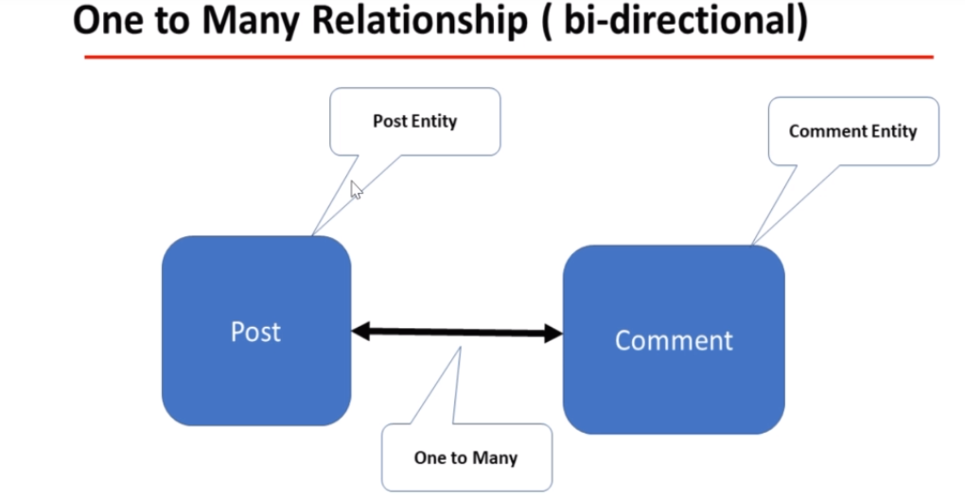

**ER(Entity Relationship Diagram)**

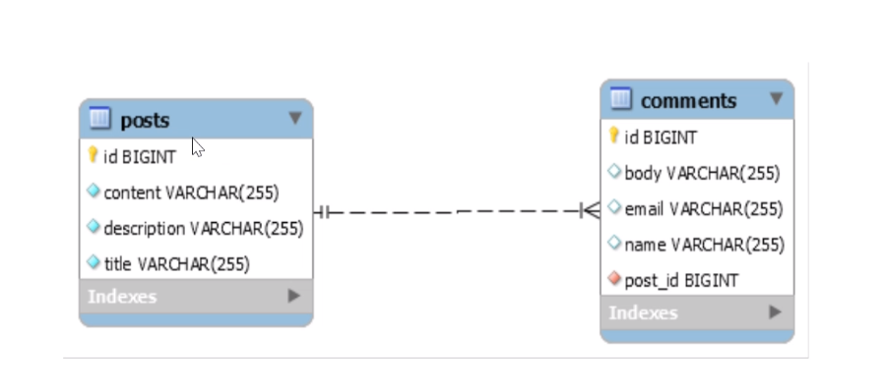

**URL Documentation with status code:**

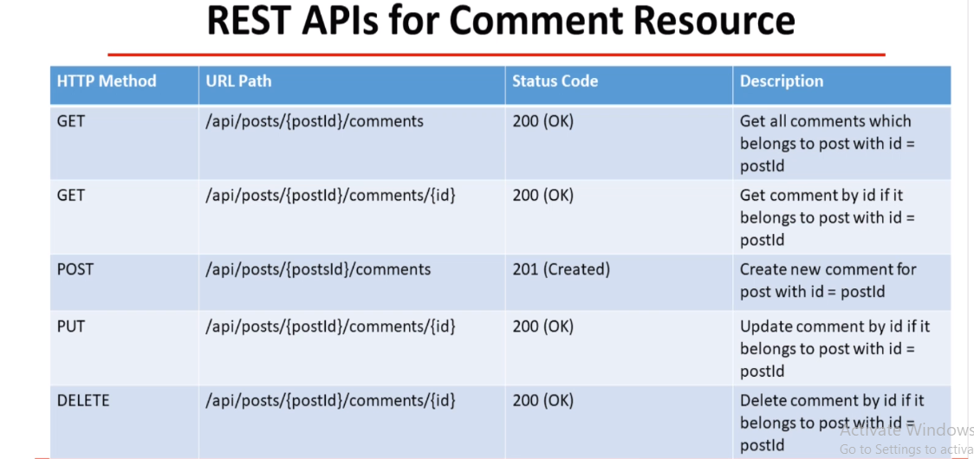

**Step 1: Create Comment Entity Class and do oneTomany bidirectional mapping**

**import lombok.AllArgsConstructor;**

**import lombok.Data;**

**import lombok.NoArgsConstructor;**

**import javax.persistence.*;**

**@Data**

**@AllArgsConstructor**

**@NoArgsConstructor**

**@Entity**

**@Table(name = "comments")**

**public class Comment {**

**@Id**

**@GeneratedValue(strategy = GenerationType.IDENTITY)**

**private long id;**

**private String name;**

**private String email;**

**private String body;**

**@ManyToOne(fetch = FetchType.LAZY)**

**@JoinColumn(name = "post_id", nullable = false)**

**private Post post;**

**}**

**Step 2: Update Post Entity Class:**

**import lombok.*;**

**import javax.persistence.*;**

**import java.util.HashSet;**

**import java.util.Set;**

**@Getter**

**@Setter**

**@AllArgsConstructor**

**@NoArgsConstructor**

**@Entity**

**@Table(**

**name = "posts", uniqueConstraints = {@UniqueConstraint(columnNames = {"title"})}**

**)**

**public class Post {**

**@Id**

**@GeneratedValue(**

**strategy = GenerationType.IDENTITY**

**)**

**private Long id;**

**@Column(name = "title", nullable = false)**

**private String title;**

**@Column(name = "description", nullable = false)**

**private String description;**

**@Column(name = "content", nullable = false)**

**private String content;**

**@OneToMany(mappedBy = "post", cascade = CascadeType.ALL, orphanRemoval = true)**

**private Set<Comment> comments = new HashSet<>();**

**}**

**Step 3: Create CommentDto class**

**@Data**

**public class CommentDto {**

**private long id;**

**private String name;**

**private String email;**

**private String body;**

**}**

**Step 4: Create CommentService Interface:**

**import java.util.List;**

**public interface CommentService {**

**CommentDto createComment(long postId, CommentDto commentDto);**

**}**

**Step 5: Create CommentServiceImpl class:**

**@Service**

**public class CommentServiceImpl implements CommentService {**

**private CommentRepository commentRepository;**

**private PostRepository postRepository;**

**private ModelMapper mapper;**

**public CommentServiceImpl(CommentRepository commentRepository,**

**PostRepository postRepository, ModelMapper mapper) {**

**this.commentRepository = commentRepository;**

**this.postRepository = postRepository;**

**this.mapper = mapper;**

**}**

**@Override**

**public CommentDto createComment(long postId, CommentDto commentDto) {**

**Comment comment = mapToEntity(commentDto);**

**// retrieve post entity by id**

**Post post = postRepository.findById(postId).orElseThrow(**

**() -> new ResourceNotFoundException("Post", "id", postId));**

**// set post to comment entity**

**comment.setPost(post);**

**// comment entity to DB**

**Comment newComment = commentRepository.save(comment);**

**return mapToDTO(newComment);**

**}**

**private CommentDto mapToDTO(Comment comment){**

**CommentDto commentDto = mapper.map(comment, CommentDto.class);**

**CommentDto commentDto = new CommentDto();**

**commentDto.setId(comment.getId());**

**commentDto.setName(comment.getName());**

**commentDto.setEmail(comment.getEmail());**

**commentDto.setBody(comment.getBody());**

**return commentDto;**

**}**

**private Comment mapToEntity(CommentDto commentDto){**

**Comment comment = mapper.map(commentDto, Comment.class);**

**Comment comment = new Comment();**

**comment.setId(commentDto.getId());**

**comment.setName(commentDto.getName());**

**comment.setEmail(commentDto.getEmail());**

**comment.setBody(commentDto.getBody());**

**return comment;**

**}**

**}**

**Step 6: Create RestController CommentController Class:**

**@RestController**

**@RequestMapping("/api/")**

**public class CommentController {**

**private CommentService commentService;**

**public CommentController(CommentService commentService) {**

**this.commentService = commentService;**

**}**

**@PostMapping("/posts/{postId}/comments")**

**public ResponseEntity<CommentDto> createComment(@PathVariable(value = "postId") long postId,**

**@RequestBody CommentDto commentDto){**

**return new ResponseEntity<>(commentService.createComment(postId, commentDto), HttpStatus.CREATED);**

**}**

**}**

**Get All Comments By PostId**

**Step 1: Update CommentRepository as shown below:**

**import org.springframework.data.jpa.repository.JpaRepository;**

**import java.util.List;**

**public interface CommentRepository extends JpaRepository<Comment, Long> {**

**List<Comment> findByPostId(long postId);**

**}**

**Step 2: Update CommentService Interface:**

**import java.util.List;**

**public interface CommentService {**

**CommentDto createComment(long postId, CommentDto commentDto);**

**List<CommentDto> getCommentsByPostId(long postId);**

**}**

**Step 3: Update CommentServiceImpl Class:**

**@Service**

**public class CommentServiceImpl implements CommentService {**

**private CommentRepository commentRepository;**

**private PostRepository postRepository;**

**private ModelMapper mapper;**

**public CommentServiceImpl(CommentRepository commentRepository, PostRepository postRepository, ModelMapper mapper) {**

**this.commentRepository = commentRepository;**

**this.postRepository = postRepository;**

**this.mapper = mapper;**

**}**

**@Override**

**public CommentDto createComment(long postId, CommentDto commentDto) {**

**Comment comment = mapToEntity(commentDto);**

**// retrieve post entity by id**

**Post post = postRepository.findById(postId).orElseThrow(**

**() -> new ResourceNotFoundException("Post", "id", postId));**

**// set post to comment entity**

**comment.setPost(post);**

**// comment entity to DB**

**Comment newComment = commentRepository.save(comment);**

**return mapToDTO(newComment);**

**}**

**@Override**

**public List<CommentDto> getCommentsByPostId(long postId) {**

**// retrieve comments by postId**

**List<Comment> comments = commentRepository.findByPostId(postId);**

**// convert list of comment entities to list of comment dto's**

**return comments.stream().map(comment -> mapToDTO(comment)).collect(Collectors.toList());**

**}**

**private CommentDto mapToDTO(Comment comment){**

**CommentDto commentDto = mapper.map(comment, CommentDto.class);**

**CommentDto commentDto = new CommentDto();**

**commentDto.setId(comment.getId());**

**commentDto.setName(comment.getName());**

**commentDto.setEmail(comment.getEmail());**

**commentDto.setBody(comment.getBody());**

**return commentDto;**

**}**

**private Comment mapToEntity(CommentDto commentDto){**

**Comment comment = mapper.map(commentDto, Comment.class);**

**Comment comment = new Comment();**

**comment.setId(commentDto.getId());**

**comment.setName(commentDto.getName());**

**comment.setEmail(commentDto.getEmail());**

**comment.setBody(commentDto.getBody());**

**return comment;**

**}**

**}**

**Step 4: Create handler method in CommentController Layer:**

**@RestController**

**@RequestMapping("/api/")**

**public class CommentController {**

**private CommentService commentService;**

**public CommentController(CommentService commentService) {**

**this.commentService = commentService;**

**}**

**@PostMapping("/posts/{postId}/comments")**

**public ResponseEntity<CommentDto> createComment(@PathVariable(value = "postId") long postId, @RequestBody CommentDto commentDto){**

**return new ResponseEntity<>(commentService.createComment(postId, commentDto), HttpStatus.CREATED);**

**}**

**@GetMapping("/posts/{postId}/comments")**

**public List<CommentDto> getCommentsByPostId(@PathVariable(value = "postId") Long postId){**

**return commentService.getCommentsByPostId(postId);**

**}**

**}**

**Get Comment By CommentId**

**Step 1: Update CommentService interface:**

**import java.util.List;**

**public interface CommentService {**

**CommentDto createComment(long postId, CommentDto commentDto);**

**List<CommentDto> getCommentsByPostId(long postId);**

**CommentDto getCommentById(Long postId, Long commentId);**

**}**

**Step 2: Create BlogApi Exception class:**

**import org.springframework.http.HttpStatus;**

**public class BlogAPIException extends RuntimeException {**

**private HttpStatus status;**

**private String message;**

**public BlogAPIException(HttpStatus status, String message) {**

**this.status = status;**

**this.message = message;**

**}**

**public BlogAPIException(String message, HttpStatus status, String message1) {**

**super(message);**

**this.status = status;**

**this.message = message1;**

**}**

**public HttpStatus getStatus() {**

**return status;**

**}**

**@Override**

**public String getMessage() {**

**return message;**

**}**

**}**

**Step 3: Update CommentServiceImpl class:**

**@Service**

**public class CommentServiceImpl implements CommentService {**

**private CommentRepository commentRepository;**

**private PostRepository postRepository;**

**private ModelMapper mapper;**

**public CommentServiceImpl(CommentRepository commentRepository, PostRepository postRepository, ModelMapper mapper) {**

**this.commentRepository = commentRepository;**

**this.postRepository = postRepository;**

**this.mapper = mapper;**

**}**

**@Override**

**public CommentDto createComment(long postId, CommentDto commentDto) {**

**Comment comment = mapToEntity(commentDto);**

**// retrieve post entity by id**

**Post post = postRepository.findById(postId).orElseThrow(**

**() -> new ResourceNotFoundException("Post", "id", postId));**

**// set post to comment entity**

**comment.setPost(post);**

**// comment entity to DB**

**Comment newComment = commentRepository.save(comment);**

**return mapToDTO(newComment);**

**}**

**@Override**

**public List<CommentDto> getCommentsByPostId(long postId) {**

**// retrieve comments by postId**

**List<Comment> comments = commentRepository.findByPostId(postId);**

**// convert list of comment entities to list of comment dto's**

**return comments.stream().map(comment -> mapToDTO(comment)).collect(Collectors.toList());**

**}**

**@Override**

**public CommentDto getCommentById(Long postId, Long commentId) {**

**// retrieve post entity by id**

**Post post = postRepository.findById(postId).orElseThrow(**

**() -> new ResourceNotFoundException("Post", "id", postId));**

**// retrieve comment by id**

**Comment comment = commentRepository.findById(commentId).orElseThrow(() ->**

**new ResourceNotFoundException("Comment", "id", commentId));**

**if(!comment.getPost().getId().equals(post.getId())){**

**throw new BlogAPIException(HttpStatus.BAD_REQUEST, "Comment does not belong to post");**

**}**

**return mapToDTO(comment);**

**}**

**private CommentDto mapToDTO(Comment comment){**

**CommentDto commentDto = mapper.map(comment, CommentDto.class);**

**CommentDto commentDto = new CommentDto();**

**commentDto.setId(comment.getId());**

**commentDto.setName(comment.getName());**

**commentDto.setEmail(comment.getEmail());**

**commentDto.setBody(comment.getBody());**

**return commentDto;**

**}**

**private Comment mapToEntity(CommentDto commentDto){**

**Comment comment = mapper.map(commentDto, Comment.class);**

**Comment comment = new Comment();**

**comment.setId(commentDto.getId());**

**comment.setName(commentDto.getName());**

**comment.setEmail(commentDto.getEmail());**

**comment.setBody(commentDto.getBody());**

**return comment;**

**}**

**}**

**Step 4: Update CommentController class:**

**@RestController**

**@RequestMapping("/api/")**

**public class CommentController {**

**private CommentService commentService;**

**public CommentController(CommentService commentService) {**

**this.commentService = commentService;**

**}**

**@PostMapping("/posts/{postId}/comments")**

**public ResponseEntity<CommentDto> createComment(@PathVariable(value = "postId") long postId,**

**@RequestBody CommentDto commentDto){**

**return new ResponseEntity<>(commentService.createComment(postId, commentDto), HttpStatus.CREATED);**

**}**

**@GetMapping("/posts/{postId}/comments")**

**public List<CommentDto> getCommentsByPostId(@PathVariable(value = "postId") Long postId){**

**return commentService.getCommentsByPostId(postId);**

**}**

**@GetMapping("/posts/{postId}/comments/{id}")**

**public ResponseEntity<CommentDto> getCommentById(@PathVariable(value = "postId") Long postId,**

**@PathVariable(value = "id") Long commentId){**

**CommentDto commentDto = commentService.getCommentById(postId, commentId);**

**return new ResponseEntity<>(commentDto, HttpStatus.OK);**

**}**

**}**

**Developing Update Comment Rest API**

Rest api url: [http://localhost:8080/api/posts/{postId}/comments/{id}](http://localhost:8080/api/posts/%7bpostId%7d/comments/%7bid%7d)

Step 1: Update CommentController with following handler method:

**@PutMapping("/posts/{postId}/comments/{id}")**

**public ResponseEntity<CommentDto> updateComment(@PathVariable(value = "postId") Long postId,**

**@PathVariable(value = "id") Long commentId,**

**@RequestBody CommentDto commentDto){**

**CommentDto updatedComment = commentService.updateComment(postId, commentId, commentDto);**

**return new ResponseEntity<>(updatedComment, HttpStatus.OK);**

**}**

**Step 2: Update CommentService Interface:**

**import java.util.List;**

**public interface CommentService {**

**CommentDto createComment(long postId, CommentDto commentDto);**

**List<CommentDto> getCommentsByPostId(long postId);**

**CommentDto getCommentById(Long postId, Long commentId);**

**CommentDto updateComment(Long postId, long commentId, CommentDto commentRequest);**

**}**

**Step 3: Update CommentServiceImpl class:**

**@Override**

**public CommentDto updateComment(Long postId, long commentId, CommentDto commentRequest) {**

**// retrieve post entity by id**

**Post post = postRepository.findById(postId).orElseThrow(**

**() -> new ResourceNotFoundException("Post", "id", postId));**

**// retrieve comment by id**

**Comment comment = commentRepository.findById(commentId).orElseThrow(() ->**

**new ResourceNotFoundException("Comment", "id", commentId));**

**if(!comment.getPost().getId().equals(post.getId())){**

**throw new BlogAPIException(HttpStatus.BAD_REQUEST, "Comment does not belongs to post");**

**}**

**comment.setName(commentRequest.getName());**

**comment.setEmail(commentRequest.getEmail());**

**comment.setBody(commentRequest.getBody());**

**Comment updatedComment = commentRepository.save(comment);**

**return mapToDTO(updatedComment);**

**}**

**Perform Testing in PostMan:**

**Delete Comment Feature**

**URL: http://localhost:8080/api/posts/{postId}/comments/{id}**

**Step 1: Update CommentController Class:**

**@DeleteMapping("/posts/{postId}/comments/{id}")**

**public ResponseEntity<String> deleteComment(@PathVariable(value = "postId") Long postId,**

**@PathVariable(value = "id") Long commentId){**

**commentService.deleteComment(postId, commentId);**

**return new ResponseEntity<>("Comment deleted successfully", HttpStatus.OK);**

**}**

**Step 2: Update CommentService Interface**

**import java.util.List;**

**public interface CommentService {**

**CommentDto createComment(long postId, CommentDto commentDto);**

**List<CommentDto> getCommentsByPostId(long postId);**

**CommentDto getCommentById(Long postId, Long commentId);**

**CommentDto updateComment(Long postId, long commentId, CommentDto commentRequest);**

**void deleteComment(Long postId, Long commentId);**

**}**

**Step 3: Update CommentServiceImpl class**

**@Override**

**public void deleteComment(Long postId, Long commentId) {**

**// retrieve post entity by id**

**Post post = postRepository.findById(postId).orElseThrow(**

**() -> new ResourceNotFoundException("Post", "id", postId));**

**// retrieve comment by id**

**Comment comment = commentRepository.findById(commentId).orElseThrow(() ->**

**new ResourceNotFoundException("Comment", "id", commentId));**

**if(!comment.getPost().getId().equals(post.getId())){**

**throw new BlogAPIException(HttpStatus.BAD_REQUEST, "Comment does not belongs to post");**

**}**

**commentRepository.delete(comment);**

**}**

**ModelMapper library or MapStruct**

**Step 1: Add the following dependency:**

**<!-- https://mvnrepository.com/artifact/org.modelmapper/modelmapper -->**

**<dependency>**

**<groupId>org.modelmapper</groupId>**

**<artifactId>modelmapper</artifactId>**

**<version>2.3.9</version>**

**</dependency>**

**Step 2: Update PostServiceImpl class as shown below:**

**@Service**

**public class PostServiceImpl implements PostService {**

**private PostRepository postRepository;**

**private ModelMapper mapper;**

**public PostServiceImpl(PostRepository postRepository, ModelMapper mapper) {**

**this.postRepository = postRepository;**

**this.mapper = mapper;**

**}**

**@Override**

**public PostDto createPost(PostDto postDto) {**

**// convert DTO to entity**

**Post post = mapToEntity(postDto);**

**Post newPost = postRepository.save(post);**

**// convert entity to DTO**

**PostDto postResponse = mapToDTO(newPost);**

**return postResponse;**

**}**

**@Override**

**public PostResponse getAllPosts(int pageNo, int pageSize, String sortBy, String sortDir) {**

**Sort sort = sortDir.equalsIgnoreCase(Sort.Direction.ASC.name()) ? Sort.by(sortBy).ascending()**

**: Sort.by(sortBy).descending();**

**// create Pageable instance**

**Pageable pageable = PageRequest.of(pageNo, pageSize, sort);**

**Page<Post> posts = postRepository.findAll(pageable);**

**// get content for page object**

**List<Post> listOfPosts = posts.getContent();**

**List<PostDto> content= listOfPosts.stream().map(post -> mapToDTO(post)).collect(Collectors.toList());**

**PostResponse postResponse = new PostResponse();**

**postResponse.setContent(content);**

**postResponse.setPageNo(posts.getNumber());**

**postResponse.setPageSize(posts.getSize());**

**postResponse.setTotalElements(posts.getTotalElements());**

**postResponse.setTotalPages(posts.getTotalPages());**

**postResponse.setLast(posts.isLast());**

**return postResponse;**

**}**

**@Override**

**public PostDto getPostById(long id) {**

**Post post = postRepository.findById(id).orElseThrow(() -> new ResourceNotFoundException("Post", "id", id));**

**return mapToDTO(post);**

**}**

**@Override**

**public PostDto updatePost(PostDto postDto, long id) {**

**// get post by id from the database**

**Post post = postRepository.findById(id).orElseThrow(() -> new ResourceNotFoundException("Post", "id", id));**

**post.setTitle(postDto.getTitle());**

**post.setDescription(postDto.getDescription());**

**post.setContent(postDto.getContent());**

**Post updatedPost = postRepository.save(post);**

**return mapToDTO(updatedPost);**

**}**

**@Override**

**public void deletePostById(long id) {**

**// get post by id from the database**

**Post post = postRepository.findById(id).orElseThrow(() -> new ResourceNotFoundException("Post", "id", id));**

**postRepository.delete(post);**

**}**

**// convert Entity into DTO**

**private PostDto mapToDTO(Post post){**

**PostDto postDto = mapper.map(post, PostDto.class);**

**// PostDto postDto = new PostDto();**

**// postDto.setId(post.getId());**

**// postDto.setTitle(post.getTitle());**

**// postDto.setDescription(post.getDescription());**

**// postDto.setContent(post.getContent());**

**return postDto;**

**}**

**// convert DTO to entity**

**private Post mapToEntity(PostDto postDto){**

**Post post = mapper.map(postDto, Post.class);**

**// Post post = new Post();**

**// post.setTitle(postDto.getTitle());**

**// post.setDescription(postDto.getDescription());**

**// post.setContent(postDto.getContent());**

**return post;**

**}**

**}**

**Step 3: Update CommentServiceImpl class:**

**@Service**

**public class CommentServiceImpl implements CommentService {**

**private CommentRepository commentRepository;**

**private PostRepository postRepository;**

**private ModelMapper mapper;**

**public CommentServiceImpl(CommentRepository commentRepository, PostRepository postRepository, ModelMapper mapper) {**

**this.commentRepository = commentRepository;**

**this.postRepository = postRepository;**

**this.mapper = mapper;**

**}**

**@Override**

**public CommentDto createComment(long postId, CommentDto commentDto) {**

**Comment comment = mapToEntity(commentDto);**

**// retrieve post entity by id**

**Post post = postRepository.findById(postId).orElseThrow(**

**() -> new ResourceNotFoundException("Post", "id", postId));**

**// set post to comment entity**

**comment.setPost(post);**

**// comment entity to DB**

**Comment newComment = commentRepository.save(comment);**

**return mapToDTO(newComment);**

**}**

**@Override**

**public List<CommentDto> getCommentsByPostId(long postId) {**

**// retrieve comments by postId**

**List<Comment> comments = commentRepository.findByPostId(postId);**

**// convert list of comment entities to list of comment dto's**

**return comments.stream().map(comment -> mapToDTO(comment)).collect(Collectors.toList());**

**}**

**@Override**

**public CommentDto getCommentById(Long postId, Long commentId) {**

**// retrieve post entity by id**

**Post post = postRepository.findById(postId).orElseThrow(**

**() -> new ResourceNotFoundException("Post", "id", postId));**

**// retrieve comment by id**

**Comment comment = commentRepository.findById(commentId).orElseThrow(() ->**

**new ResourceNotFoundException("Comment", "id", commentId));**

**if(!comment.getPost().getId().equals(post.getId())){**

**throw new BlogAPIException(HttpStatus.BAD_REQUEST, "Comment does not belong to post");**

**}**

**return mapToDTO(comment);**

**}**

**@Override**

**public CommentDto updateComment(Long postId, long commentId, CommentDto commentRequest) {**

**// retrieve post entity by id**

**Post post = postRepository.findById(postId).orElseThrow(**

**() -> new ResourceNotFoundException("Post", "id", postId));**

**// retrieve comment by id**

**Comment comment = commentRepository.findById(commentId).orElseThrow(() ->**

**new ResourceNotFoundException("Comment", "id", commentId));**

**if(!comment.getPost().getId().equals(post.getId())){**

**throw new BlogAPIException(HttpStatus.BAD_REQUEST, "Comment does not belongs to post");**

**}**

**comment.setName(commentRequest.getName());**

**comment.setEmail(commentRequest.getEmail());**

**comment.setBody(commentRequest.getBody());**

**Comment updatedComment = commentRepository.save(comment);**

**return mapToDTO(updatedComment);**

**}**

**@Override**

**public void deleteComment(Long postId, Long commentId) {**

**// retrieve post entity by id**

**Post post = postRepository.findById(postId).orElseThrow(**

**() -> new ResourceNotFoundException("Post", "id", postId));**

**// retrieve comment by id**

**Comment comment = commentRepository.findById(commentId).orElseThrow(() ->**

**new ResourceNotFoundException("Comment", "id", commentId));**

**if(!comment.getPost().getId().equals(post.getId())){**

**throw new BlogAPIException(HttpStatus.BAD_REQUEST, "Comment does not belongs to post");**

**}**

**commentRepository.delete(comment);**

**}**

**private CommentDto mapToDTO(Comment comment){**

**CommentDto commentDto = mapper.map(comment, CommentDto.class);**

**// CommentDto commentDto = new CommentDto();**

**// commentDto.setId(comment.getId());**

**// commentDto.setName(comment.getName());**

**// commentDto.setEmail(comment.getEmail());**

**// commentDto.setBody(comment.getBody());**

**return commentDto;**

**}**

**private Comment mapToEntity(CommentDto commentDto){**

**Comment comment = mapper.map(commentDto, Comment.class);**

**// Comment comment = new Comment();**

**// comment.setId(commentDto.getId());**

**// comment.setName(commentDto.getName());**

**// comment.setEmail(commentDto.getEmail());**

**// comment.setBody(commentDto.getBody());**

**return comment;**

**}**

**}**

**Exception Handling – Specific Exception & Global Exception**

**Step 1: Create ErrorDetails class in payload package**

**import java.util.Date;**

**public class ErrorDetails {**

**private Date timestamp;**

**private String message;**

**private String details;**

**public ErrorDetails(Date timestamp, String message, String details) {**

**this.timestamp = timestamp;**

**this.message = message;**

**this.details = details;**

**}**

**public Date getTimestamp() {**

**return timestamp;**

**}**

**public String getMessage() {**

**return message;**

**}**

**public String getDetails() {**

**return details;**

**}**

**}**

**Step 2: Create GlobalExceptionHandler class in exceptionpackage**

**import com.springboot.blog.payload.ErrorDetails;**

**import org.springframework.http.HttpHeaders;**

**import org.springframework.http.HttpStatus;**

**import org.springframework.http.ResponseEntity;**

**import org.springframework.validation.FieldError;**

**import org.springframework.web.bind.MethodArgumentNotValidException;**

**import org.springframework.web.bind.annotation.ControllerAdvice;**

**import org.springframework.web.bind.annotation.ExceptionHandler;**

**import org.springframework.web.context.request.WebRequest;**

**import org.springframework.web.servlet.mvc.method.annotation.ResponseEntityExceptionHandler;**

**import java.util.Date;**

**import java.util.HashMap;**

**import java.util.Map;**

**@ControllerAdvice**

**public class GlobalExceptionHandler extends ResponseEntityExceptionHandler {**

**// handle specific exceptions**

**@ExceptionHandler(ResourceNotFoundException.class)**

**public ResponseEntity<ErrorDetails> handleResourceNotFoundException(ResourceNotFoundException exception,**

**WebRequest webRequest){**

**ErrorDetails errorDetails = new ErrorDetails(new Date(), exception.getMessage(),**

**webRequest.getDescription(false));**

**return new ResponseEntity<>(errorDetails, HttpStatus.NOT_FOUND);**

**}**

**@ExceptionHandler(BlogAPIException.class)**

**public ResponseEntity<ErrorDetails> handleBlogAPIException(BlogAPIException exception,**

**WebRequest webRequest){**

**ErrorDetails errorDetails = new ErrorDetails(new Date(), exception.getMessage(),**

**webRequest.getDescription(false));**

**return new ResponseEntity<>(errorDetails, HttpStatus.BAD_REQUEST);**

**}**

**// global exceptions**

**@ExceptionHandler(Exception.class)**

**public ResponseEntity<ErrorDetails> handleGlobalException(Exception exception,**

**WebRequest webRequest){**

**ErrorDetails errorDetails = new ErrorDetails(new Date(), exception.getMessage(),**

**webRequest.getDescription(false));**

**return new ResponseEntity<>(errorDetails, HttpStatus.INTERNAL_SERVER_ERROR);**

**}**

**}**

**Spring Validations**

**Step 1: Add dependency in pom.xml file**

**<!-- https://mvnrepository.com/artifact/org.springframework.boot/spring-boot-starter-validation -->**

**<dependency>**

**<groupId>org.springframework.boot</groupId>**

**<artifactId>spring-boot-starter-validation</artifactId>**

**</dependency>**

**Step 2: Add Validation annotations in DTO classes**

**package com.springboot.blog.payload;**

**import io.swagger.annotations.ApiModel;**

**import io.swagger.annotations.ApiModelProperty;**

**import lombok.Data;**

**import javax.validation.constraints.NotEmpty;**

**import javax.validation.constraints.Size;**

**import java.util.Set;**

**@ApiModel(description = "Post model information")**

**@Data**

**public class PostDto {**

**private long id;**

**// title should not be null or empty**

**// title should have at least 2 characters**

**@NotEmpty**

**@Size(min = 2, message = "Post title should have at least 2 characters")**

**private String title;**

**// post description should be not null or empty**

**// post description should have at least 10 characters**

**@NotEmpty**

**@Size(min = 10, message = "Post description should have at least 10 characters")**

**private String description;**

**// post content should not be null or empty**

**@NotEmpty**

**private String content;**

**private Set<CommentDto> comments;**

**}**

**Step 3: Add @Valid annotation in controller class:**

**import com.springboot.blog.payload.PostDto;**

**import com.springboot.blog.payload.PostResponse;**

**import com.springboot.blog.service.PostService;**

**import com.springboot.blog.utils.AppConstants;**

**import io.swagger.annotations.Api;**

**import io.swagger.annotations.ApiOperation;**

**import io.swagger.annotations.ApiResponses;**

**import org.springframework.http.HttpStatus;**

**import org.springframework.http.ResponseEntity;**

**import org.springframework.security.access.prepost.PreAuthorize;**

**import org.springframework.web.bind.annotation.*;**

**import javax.validation.Valid;**

**@RestController**

**@RequestMapping()**

**public class PostController {**

**private PostService postService;**

**public PostController(PostService postService) {**

**this.postService = postService;**

**}**

**// create blog post rest api**

**@PostMapping("/api/v1/posts")**

**public ResponseEntity<PostDto> createPost(@Valid @RequestBody PostDto postDto){**

**if(result.hasErrors()){  
 return new ResponseEntity<>(result.getFieldError().getDefaultMessage(), HttpStatus.*INTERNAL_SERVER_ERROR*);  
}**

**return new ResponseEntity<>(postService.createPost(postDto), HttpStatus.CREATED);**

**}**

**// get all posts rest api**

**@GetMapping("/api/v1/posts")**

**public PostResponse getAllPosts(**

**@RequestParam(value = "pageNo", defaultValue = AppConstants.DEFAULT_PAGE_NUMBER, required = false) int pageNo,**

**@RequestParam(value = "pageSize", defaultValue = AppConstants.DEFAULT_PAGE_SIZE, required = false) int pageSize,**

**@RequestParam(value = "sortBy", defaultValue = AppConstants.DEFAULT_SORT_BY, required = false) String sortBy,**

**@RequestParam(value = "sortDir", defaultValue = AppConstants.DEFAULT_SORT_DIRECTION, required = false) String sortDir**

**){**

**return postService.getAllPosts(pageNo, pageSize, sortBy, sortDir);**

**}**

**// get post by id**

**@GetMapping(value = "/api/v1/posts/{id}")**

**public ResponseEntity<PostDto> getPostByIdV1(@PathVariable(name = "id") long id){**

**return ResponseEntity.ok(postService.getPostById(id));**

**}**

**// update post by id rest api**

**@PutMapping("/api/v1/posts/{id}")**

**public ResponseEntity<PostDto> updatePost(@Valid @RequestBody PostDto postDto, @PathVariable(name = "id") long id){**

**PostDto postResponse = postService.updatePost(postDto, id);**

**return new ResponseEntity<>(postResponse, HttpStatus.OK);**

**}**

**// delete post rest api**

**@DeleteMapping("/api/v1/posts/{id}")**

**public ResponseEntity<String> deletePost(@PathVariable(name = "id") long id){**

**postService.deletePostById(id);**

**return new ResponseEntity<>("Post entity deleted successfully.", HttpStatus.OK);**

**}**

**}**

**Spring Security**

**Step 1: Add Spring Dependency Jar**

<dependency>

<groupId>org.springframework.boot</groupId>

<artifactId>spring-boot-starter-security</artifactId>

</dependency>

**Step 2: All Links of rest api are now secured**

**Step 3: Update application.properties file**

**Spring.security.user.name=pankaj**

**Spring.security.user.password=password**

**Spring.security.user.roles=ADMIN**

**Step 4: Implementing basic authentication**

**Develop config package**

**Step 5: Develop SecurityConfig class and Extend WebSecurityConfigurerAdapter**

**@Configuration**

**@EnableWebSecurity**

**public class SecurityConfig extends WebSecurityConfigurerAdapter {**

**@Override**

**protected void configure(HttpSecurity http) throws Exception {**

**http**

**.csrf().disable()**

**.authorizeRequests()**

**.anyRequest()**

**.authenticated()**

**.and()**

**.httpBasic();**

**}**

**}**

**In memory Authentication**

**Step 1: Update SecurityConfig class as shown below:**

package com.springboot.blog.config;  
  
import org.springframework.context.annotation.Bean;  
import org.springframework.context.annotation.Configuration;  
import org.springframework.http.HttpMethod;  
import org.springframework.security.config.annotation.method.configuration.EnableGlobalMethodSecurity;  
import org.springframework.security.config.annotation.web.builders.HttpSecurity;  
import org.springframework.security.config.annotation.web.configuration.EnableWebSecurity;  
import org.springframework.security.config.annotation.web.configuration.WebSecurityConfigurerAdapter;  
import org.springframework.security.core.userdetails.User;  
import org.springframework.security.core.userdetails.UserDetails;  
import org.springframework.security.core.userdetails.UserDetailsService;  
import org.springframework.security.crypto.bcrypt.BCryptPasswordEncoder;  
import org.springframework.security.crypto.password.PasswordEncoder;  
import org.springframework.security.provisioning.InMemoryUserDetailsManager;  
  
  
@Configuration  
@EnableWebSecurity  
@EnableGlobalMethodSecurity(prePostEnabled = true)  
public class SecurityConfig extends WebSecurityConfigurerAdapter {  
  
  
 @Bean  
 PasswordEncoder passwordEncoder(){  
 return new BCryptPasswordEncoder();  
 }  
  
 @Override  
 protected void configure(HttpSecurity http) throws Exception {  
 http  
 .csrf().disable()  
 .authorizeRequests()  
 .antMatchers(HttpMethod.*GET*, "/api/**").permitAll()  
 .anyRequest()  
 .authenticated()  
 .and()  
 .httpBasic();  
 }  
  
  
  
 @Override  
 @Bean  
 protected UserDetailsService userDetailsService() {  
 UserDetails ramesh = User.*builder*().username("pankaj").password(passwordEncoder()  
 .encode("password")).roles("USER").build();  
 UserDetails admin = User.*builder*().username("admin").password(passwordEncoder()  
 .encode("admin")).roles("ADMIN").build();  
 return new InMemoryUserDetailsManager(ramesh, admin);  
 }  
}

**Step 2: Add @PreAuthorize(“hasRole(‘ADMIN’)”) Annotation in controller layer**

package com.springboot.blog.controller;  
  
import com.springboot.blog.payload.PostDto;  
import com.springboot.blog.payload.PostResponse;  
import com.springboot.blog.service.PostService;  
import com.springboot.blog.utils.AppConstants;  
import org.springframework.http.HttpStatus;  
import org.springframework.http.ResponseEntity;  
import org.springframework.security.access.prepost.PreAuthorize;  
import org.springframework.web.bind.annotation.*;  
  
import javax.validation.Valid;  
import java.util.List;  
  
@RestController  
@RequestMapping("/api/posts")  
public class PostController {  
  
 private PostService postService;  
  
 public PostController(PostService postService) {  
 this.postService = postService;  
 }  
  
 @PreAuthorize("hasRole('ADMIN')")  
 *// create blog post rest api* @PostMapping  
 public ResponseEntity<PostDto> createPost(@Valid @RequestBody PostDto postDto){  
 return new ResponseEntity<>(postService.createPost(postDto), HttpStatus.*CREATED*);  
 }  
  
 *// get all posts rest api* @GetMapping  
 public PostResponse getAllPosts(  
 @RequestParam(value = "pageNo", defaultValue = AppConstants.*DEFAULT_PAGE_NUMBER*, required = false) int pageNo,  
 @RequestParam(value = "pageSize", defaultValue = AppConstants.*DEFAULT_PAGE_SIZE*, required = false) int pageSize,  
 @RequestParam(value = "sortBy", defaultValue = AppConstants.*DEFAULT_SORT_BY*, required = false) String sortBy,  
 @RequestParam(value = "sortDir", defaultValue = AppConstants.*DEFAULT_SORT_DIRECTION*, required = false) String sortDir  
 ){  
 return postService.getAllPosts(pageNo, pageSize, sortBy, sortDir);  
 }  
  
 *// get post by id* @GetMapping("/{id}")  
 public ResponseEntity<PostDto> getPostById(@PathVariable(name = "id") long id){  
 return ResponseEntity.*ok*(postService.getPostById(id));  
 }  
  
 @PreAuthorize("hasRole('ADMIN')")  
 *// update post by id rest api* @PutMapping("/{id}")  
 public ResponseEntity<PostDto> updatePost(@Valid @RequestBody PostDto postDto, @PathVariable(name = "id") long id){  
  
 PostDto postResponse = postService.updatePost(postDto, id);  
  
 return new ResponseEntity<>(postResponse, HttpStatus.*OK*);  
 }  
  
 @PreAuthorize("hasRole('ADMIN')")  
 *// delete post rest api* @DeleteMapping("/{id}")  
 public ResponseEntity<String> deletePost(@PathVariable(name = "id") long id){  
  
 postService.deletePostById(id);  
  
 return new ResponseEntity<>("Post entity deleted successfully.", HttpStatus.*OK*);  
 }  
}

**Create JPA Entities User & Role**

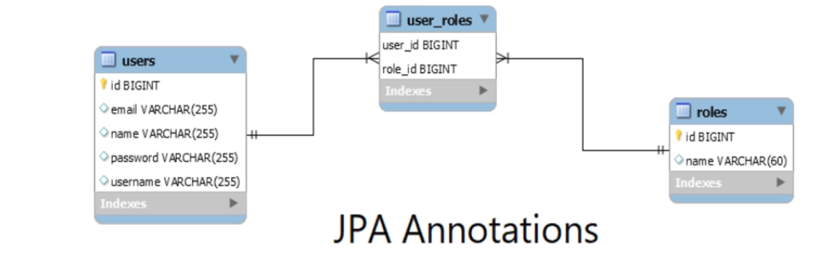

**Step 1: Create user table:**

package com.springboot.blog.entity;  
  
import lombok.Data;  
  
import javax.persistence.*;  
import java.util.Set;  
  
@Data  
@Entity  
@Table(name = "users", uniqueConstraints = {  
 @UniqueConstraint(columnNames = {"username"}),  
 @UniqueConstraint(columnNames = {"email"})  
})  
public class User {  
  
 @Id  
 @GeneratedValue(strategy = GenerationType.*IDENTITY*)  
 private long id;  
 private String name;  
 private String username;  
 private String email;  
 private String password;  
  
 @ManyToMany(fetch = FetchType.*EAGER*, cascade = CascadeType.*ALL*)  
 @JoinTable(name = "user_roles",  
 joinColumns = @JoinColumn(name = "user_id", referencedColumnName = "id"),  
 inverseJoinColumns = @JoinColumn(name = "role_id", referencedColumnName = "id"))  
 private Set<Role> roles;  
}

**Step 2: Create Role Entity Class:**

package com.springboot.blog.entity;  
  
import lombok.Getter;  
import lombok.Setter;  
  
import javax.persistence.*;  
  
@Setter  
@Getter  
@Entity  
@Table(name = "roles")  
public class Role {  
  
 @Id  
 @GeneratedValue(strategy = GenerationType.*IDENTITY*)  
 private long id;  
  
 @Column(length = 60)  
 private String name;  
}

**Create Repository Layer**

**Step 1: Create UserRepository Layer**

package com.springboot.blog.repository;  
import com.springboot.blog.entity.User;  
import org.springframework.data.domain.Example;  
import org.springframework.data.jpa.repository.JpaRepository;  
  
import java.util.Optional;  
  
public interface UserRepository extends JpaRepository<User, Long> {  
 Optional<User> findByEmail(String email);  
 Optional<User> findByUsernameOrEmail(String username, String email);  
 Optional<User> findByUsername(String username);  
 Boolean existsByUsername(String username);  
 Boolean existsByEmail(String email);  
}

**Step 2: Create RoleRepository Layer**

import com.springboot.blog.entity.Role;  
import org.springframework.data.jpa.repository.JpaRepository;  
  
import java.util.Optional;  
  
public interface RoleRepository extends JpaRepository<Role, Long> {  
 Optional<Role> findByName(String name);  
}

**UserDetailsService Implementation**

**Step 1: Create CustomUserDetailsService class in security package**

package com.springboot.blog.security;  
  
  
import com.springboot.blog.entity.Role;  
import com.springboot.blog.entity.User;  
import com.springboot.blog.repository.UserRepository;  
import org.springframework.security.core.GrantedAuthority;  
import org.springframework.security.core.authority.SimpleGrantedAuthority;  
import org.springframework.security.core.userdetails.UserDetails;  
import org.springframework.security.core.userdetails.UserDetailsService;  
import org.springframework.security.core.userdetails.UsernameNotFoundException;  
import org.springframework.stereotype.Service;  
  
import java.util.Collection;  
import java.util.Set;  
import java.util.stream.Collectors;  
  
@Service  
public class CustomUserDetailsService implements UserDetailsService {  
  
 private UserRepository userRepository;  
  
 public CustomUserDetailsService(UserRepository userRepository) {  
 this.userRepository = userRepository;  
 }  
  
 @Override  
 public UserDetails loadUserByUsername(String usernameOrEmail) throws UsernameNotFoundException {  
 User user = userRepository.findByUsernameOrEmail(usernameOrEmail, usernameOrEmail)  
 .orElseThrow(() ->  
 new UsernameNotFoundException("User not found with username or email:" + usernameOrEmail));  
 return new org.springframework.security.core.userdetails.User(user.getEmail(),  
 user.getPassword(), mapRolesToAuthorities(user.getRoles()));  
 }  
  
 private Collection< ? extends GrantedAuthority> mapRolesToAuthorities(Set<Role> roles){  
 return roles.stream().map(role -> new SimpleGrantedAuthority(role.getName())).collect(Collectors.*toList*());  
 }  
}

**Step 2: Update SecurityConfig File as shown below:**

package com.springboot.blog.config;  
  
import com.springboot.blog.security.CustomUserDetailsService;  
import org.springframework.beans.factory.annotation.Autowired;  
import org.springframework.context.annotation.Bean;  
import org.springframework.context.annotation.Configuration;  
import org.springframework.http.HttpMethod;  
import org.springframework.security.config.annotation.authentication.builders.AuthenticationManagerBuilder;  
import org.springframework.security.config.annotation.method.configuration.EnableGlobalMethodSecurity;  
import org.springframework.security.config.annotation.web.builders.HttpSecurity;  
import org.springframework.security.config.annotation.web.configuration.EnableWebSecurity;  
import org.springframework.security.config.annotation.web.configuration.WebSecurityConfigurerAdapter;  
import org.springframework.security.core.userdetails.User;  
import org.springframework.security.core.userdetails.UserDetails;  
import org.springframework.security.core.userdetails.UserDetailsService;  
import org.springframework.security.crypto.bcrypt.BCryptPasswordEncoder;  
import org.springframework.security.crypto.password.PasswordEncoder;  
import org.springframework.security.provisioning.InMemoryUserDetailsManager;  
  
@Configuration  
@EnableWebSecurity  
@EnableGlobalMethodSecurity(prePostEnabled = true)  
public class SecurityConfig extends WebSecurityConfigurerAdapter {  
  
 @Autowired  
 private CustomUserDetailsService userDetailsService;  
  
 @Bean  
 PasswordEncoder passwordEncoder(){  
 return new BCryptPasswordEncoder();  
 }  
  
 @Override  
 protected void configure(HttpSecurity http) throws Exception {  
 http  
 .csrf().disable()  
 .authorizeRequests()  
 .antMatchers(HttpMethod.*GET*, "/api/**").permitAll()  
 .anyRequest()  
 .authenticated()  
 .and()  
 .httpBasic();  
 }  
  
 @Override  
 protected void configure(AuthenticationManagerBuilder auth) throws Exception {  
 auth.userDetailsService(userDetailsService)  
 .passwordEncoder(passwordEncoder());  
 }  
  
 *// @Override  
// @Bean  
// protected UserDetailsService userDetailsService() {  
// UserDetails ramesh = User.builder().username("ramesh").password(passwordEncoder()  
// .encode("password")).roles("USER").build();  
// UserDetails admin = User.builder().username("admin").password(passwordEncoder()  
// .encode("admin")).roles("ADMIN").build();  
// return new InMemoryUserDetailsManager(ramesh, admin);  
// }*}

**Developing Signin Rest API**

**Step 1: Create LoginDto class in payload package:**

import lombok.Data;

@Data

public class LoginDto {

private String usernameOrEmail;

private String password;

}

Step 2: Create AuthController class in controller package:

import com.springboot.blog.payload.LoginDto;  
import com.springboot.blog.repository.UserRepository;  
import org.springframework.beans.factory.annotation.Autowired;  
import org.springframework.http.HttpStatus;  
import org.springframework.http.ResponseEntity;  
import org.springframework.security.authentication.AuthenticationManager;  
import org.springframework.security.authentication.UsernamePasswordAuthenticationToken;  
import org.springframework.security.core.Authentication;  
import org.springframework.security.core.context.SecurityContextHolder;  
import org.springframework.web.bind.annotation.PostMapping;  
import org.springframework.web.bind.annotation.RequestBody;  
import org.springframework.web.bind.annotation.RequestMapping;  
import org.springframework.web.bind.annotation.RestController;  
  
@RestController  
@RequestMapping("/api/auth")  
public class AuthController {  
  
 @Autowired  
 private AuthenticationManager authenticationManager;  
  
 @PostMapping("/signin")  
 public ResponseEntity<String> authenticateUser(@RequestBody LoginDto loginDto){  
 Authentication authentication = authenticationManager.authenticate(  
 new UsernamePasswordAuthenticationToken(loginDto.getUsernameOrEmail(), loginDto.getPassword())  
 );  
 SecurityContextHolder.*getContext*().setAuthentication(authentication);  
 return new ResponseEntity<>("User signed-in successfully!.", HttpStatus.*OK*);  
 }  
}

Step 3: Update SecurityConfig File:

import com.springboot.blog.security.CustomUserDetailsService;  
import org.springframework.beans.factory.annotation.Autowired;  
import org.springframework.context.annotation.Bean;  
import org.springframework.context.annotation.Configuration;  
import org.springframework.http.HttpMethod;  
import org.springframework.security.authentication.AuthenticationManager;  
import org.springframework.security.config.annotation.authentication.builders.AuthenticationManagerBuilder;  
import org.springframework.security.config.annotation.method.configuration.EnableGlobalMethodSecurity;  
import org.springframework.security.config.annotation.web.builders.HttpSecurity;  
import org.springframework.security.config.annotation.web.configuration.EnableWebSecurity;  
import org.springframework.security.config.annotation.web.configuration.WebSecurityConfigurerAdapter;  
import org.springframework.security.core.userdetails.User;  
import org.springframework.security.core.userdetails.UserDetails;  
import org.springframework.security.core.userdetails.UserDetailsService;  
import org.springframework.security.crypto.bcrypt.BCryptPasswordEncoder;  
import org.springframework.security.crypto.password.PasswordEncoder;  
import org.springframework.security.provisioning.InMemoryUserDetailsManager;  
  
@Configuration  
@EnableWebSecurity  
@EnableGlobalMethodSecurity(prePostEnabled = true)  
public class SecurityConfig extends WebSecurityConfigurerAdapter {  
  
 @Autowired  
 private CustomUserDetailsService userDetailsService;  
  
 @Bean  
 PasswordEncoder passwordEncoder(){  
 return new BCryptPasswordEncoder();  
 }  
  
 @Override  
 @Bean  
 public AuthenticationManager authenticationManagerBean() throws Exception {  
 return super.authenticationManagerBean();  
 }  
  
 @Override  
 protected void configure(HttpSecurity http) throws Exception {  
 http  
 .csrf().disable()  
 .authorizeRequests()  
 .antMatchers(HttpMethod.*GET*, "/api/**").permitAll()  
 .antMatchers("/api/auth/**").permitAll()  
 .anyRequest()  
 .authenticated()  
 .and()  
 .httpBasic();  
 }  
  
 @Override  
 protected void configure(AuthenticationManagerBuilder auth) throws Exception {  
 auth.userDetailsService(userDetailsService)  
 .passwordEncoder(passwordEncoder());  
 }  
  
 *// @Override  
// @Bean  
// protected UserDetailsService userDetailsService() {  
// UserDetails ramesh = User.builder().username("ramesh").password(passwordEncoder()  
// .encode("password")).roles("USER").build();  
// UserDetails admin = User.builder().username("admin").password(passwordEncoder()  
// .encode("admin")).roles("ADMIN").build();  
// return new InMemoryUserDetailsManager(ramesh, admin);  
// }*}

Developing SignUp Feature Rest API

Step 1: Update AuthController class as shown below

package com.springboot.blog.controller;  
  
import com.springboot.blog.entity.Role;  
import com.springboot.blog.entity.User;  
import com.springboot.blog.payload.LoginDto;  
import com.springboot.blog.payload.SignUpDto;  
import com.springboot.blog.repository.RoleRepository;  
import com.springboot.blog.repository.UserRepository;  
import org.springframework.beans.factory.annotation.Autowired;  
import org.springframework.http.HttpStatus;  
import org.springframework.http.ResponseEntity;  
import org.springframework.security.authentication.AuthenticationManager;  
import org.springframework.security.authentication.UsernamePasswordAuthenticationToken;  
import org.springframework.security.core.Authentication;  
import org.springframework.security.core.context.SecurityContextHolder;  
import org.springframework.security.crypto.password.PasswordEncoder;  
import org.springframework.web.bind.annotation.PostMapping;  
import org.springframework.web.bind.annotation.RequestBody;  
import org.springframework.web.bind.annotation.RequestMapping;  
import org.springframework.web.bind.annotation.RestController;  
  
import java.util.Collections;  
  
@RestController  
@RequestMapping("/api/auth")  
public class AuthController {  
  
 @Autowired  
 private AuthenticationManager authenticationManager;  
  
 @Autowired  
 private UserRepository userRepository;  
  
 @Autowired  
 private RoleRepository roleRepository;  
  
 @Autowired  
 private PasswordEncoder passwordEncoder;  
  
 @PostMapping("/signin")  
 public ResponseEntity<String> authenticateUser(@RequestBody LoginDto loginDto){  
 Authentication authentication = authenticationManager.authenticate(new UsernamePasswordAuthenticationToken(  
 loginDto.getUsernameOrEmail(), loginDto.getPassword()));  
  
 SecurityContextHolder.*getContext*().setAuthentication(authentication);  
 return new ResponseEntity<>("User signed-in successfully!.", HttpStatus.*OK*);  
 }  
  
 @PostMapping("/signup")  
 public ResponseEntity<?> registerUser(@RequestBody SignUpDto signUpDto){  
  
 *// add check for username exists in a DB* if(userRepository.existsByUsername(signUpDto.getUsername())){  
 return new ResponseEntity<>("Username is already taken!", HttpStatus.*BAD_REQUEST*);  
 }  
  
 *// add check for email exists in DB* if(userRepository.existsByEmail(signUpDto.getEmail())){  
 return new ResponseEntity<>("Email is already taken!", HttpStatus.*BAD_REQUEST*);  
 }  
  
 *// create user object* User user = new User();  
 user.setName(signUpDto.getName());  
 user.setUsername(signUpDto.getUsername());  
 user.setEmail(signUpDto.getEmail());  
 user.setPassword(passwordEncoder.encode(signUpDto.getPassword()));  
  
 Role roles = roleRepository.findByName("ROLE_ADMIN").get();  
 user.setRoles(Collections.*singleton*(roles));  
  
 userRepository.save(user);  
  
 return new ResponseEntity<>("User registered successfully", HttpStatus.*OK*);  
  
 }  
}

Step 2: Develop SignUpDto payload class:

import lombok.Data;  
  
@Data  
public class SignUpDto {  
 private String name;  
 private String username;  
 private String email;  
 private String password;  
}

**Developing JWT Token**

**For JWT Token add the following dependency:**

<dependency>

<groupId>io.jsonwebtoken</groupId>

<artifactId>jjwt</artifactId>

<version>0.9.1</version>

</dependency>

**Step 1: In security package create JwtAuthenticationEntryPoint**

**import org.springframework.security.core.AuthenticationException;**

**import org.springframework.security.web.AuthenticationEntryPoint;**

**import org.springframework.stereotype.Component;**

**import javax.servlet.ServletException;**

**import javax.servlet.http.HttpServletRequest;**

**import javax.servlet.http.HttpServletResponse;**

**import java.io.IOException;**

**@Component**

**public class JwtAuthenticationEntryPoint implements AuthenticationEntryPoint {**

**@Override**

**public void commence(HttpServletRequest request,**

**HttpServletResponse response,**

**AuthenticationException authException) throws IOException, ServletException {**

**response.sendError(HttpServletResponse.SC_UNAUTHORIZED, authException.getMessage());**

**}**

**}**

**Step 2: Update application.properties file:**

**## App Properties**

**app.jwt-secret= JWTSecretKey**

**app.jwt-expiration-milliseconds = 604800000**

**Step 3: Develop JwtAuthenticationFilter class in security package:**

**package com.springboot.blog.security;**

**import org.springframework.beans.factory.annotation.Autowired;**

**import org.springframework.security.authentication.UsernamePasswordAuthenticationToken;**

**import org.springframework.security.core.context.SecurityContextHolder;**

**import org.springframework.security.core.userdetails.UserDetails;**

**import org.springframework.security.web.authentication.WebAuthenticationDetailsSource;**

**import org.springframework.util.StringUtils;**

**import org.springframework.web.filter.OncePerRequestFilter;**

**import javax.servlet.FilterChain;**

**import javax.servlet.ServletException;**

**import javax.servlet.http.HttpServletRequest;**

**import javax.servlet.http.HttpServletResponse;**

**import java.io.IOException;**

**public class JwtAuthenticationFilter extends OncePerRequestFilter {**

**// inject dependencies**

**@Autowired**

**private JwtTokenProvider tokenProvider;**

**@Autowired**

**private CustomUserDetailsService customUserDetailsService;**

**@Override**

**protected void doFilterInternal(HttpServletRequest request,**

**HttpServletResponse response,**

**FilterChain filterChain) throws ServletException, IOException {**

**// get JWT (token) from http request**

**String token = getJWTfromRequest(request);**

**// validate token**

**if(StringUtils.hasText(token) && tokenProvider.validateToken(token)){**

**// get username from token**

**String username = tokenProvider.getUsernameFromJWT(token);**

**// load user associated with token**

**UserDetails userDetails = customUserDetailsService.loadUserByUsername(username);**

**UsernamePasswordAuthenticationToken authenticationToken = new UsernamePasswordAuthenticationToken(**

**userDetails, null, userDetails.getAuthorities()**

**);**

**authenticationToken.setDetails(new WebAuthenticationDetailsSource().buildDetails(request));**

**// set spring security**

**SecurityContextHolder.getContext().setAuthentication(authenticationToken);**

**}**

**filterChain.doFilter(request, response);**

**}**

**// Bearer <accessToken>**

**private String getJWTfromRequest(HttpServletRequest request){**

**String bearerToken = request.getHeader("Authorization");**

**if(StringUtils.hasText(bearerToken) && bearerToken.startsWith("Bearer ")){**

**return bearerToken.substring(7, bearerToken.length());**

**}**

**return null;**

**}**

**}**

**Step 4: Develop JwtTokenProvider class in security package:**

**package com.springboot.blog.security;**

**import com.springboot.blog.exception.BlogAPIException;**

**import io.jsonwebtoken.*;**

**import org.springframework.beans.factory.annotation.Value;**

**import org.springframework.http.HttpStatus;**

**import org.springframework.security.core.Authentication;**

**import org.springframework.stereotype.Component;**

**import java.util.Date;**

**@Component**

**public class JwtTokenProvider {**

**@Value("${app.jwt-secret}")**

**private String jwtSecret;**

**@Value("${app.jwt-expiration-milliseconds}")**

**private int jwtExpirationInMs;**

**// generate token**

**public String generateToken(Authentication authentication){**

**String username = authentication.getName();**

**Date currentDate = new Date();**

**Date expireDate = new Date(currentDate.getTime() + jwtExpirationInMs);**

**String token = Jwts.builder()**

**.setSubject(username)**

**.setIssuedAt(new Date())**

**.setExpiration(expireDate)**

**.signWith(SignatureAlgorithm.HS512, jwtSecret)**

**.compact();**

**return token;**

**}**

**// get username from the token**

**public String getUsernameFromJWT(String token){**

**Claims claims = Jwts.parser()**

**.setSigningKey(jwtSecret)**

**.parseClaimsJws(token)**

**.getBody();**

**return claims.getSubject();**

**}**

**// validate JWT token**

**public boolean validateToken(String token){**

**try{**

**Jwts.parser().setSigningKey(jwtSecret).parseClaimsJws(token);**

**return true;**

**}catch (SignatureException ex){**

**throw new BlogAPIException(HttpStatus.BAD_REQUEST, "Invalid JWT signature");**

**} catch (MalformedJwtException ex) {**

**throw new BlogAPIException(HttpStatus.BAD_REQUEST, "Invalid JWT token");**

**} catch (ExpiredJwtException ex) {**

**throw new BlogAPIException(HttpStatus.BAD_REQUEST, "Expired JWT token");**

**} catch (UnsupportedJwtException ex) {**

**throw new BlogAPIException(HttpStatus.BAD_REQUEST, "Unsupported JWT token");**

**} catch (IllegalArgumentException ex) {**

**throw new BlogAPIException(HttpStatus.BAD_REQUEST, "JWT claims string is empty.");**

**}**

**}**

**}**

**Step 4: Update AuthController class:**

**import com.springboot.blog.entity.Role;**

**import com.springboot.blog.entity.User;**

**import com.springboot.blog.payload.JWTAuthResponse;**

**import com.springboot.blog.payload.LoginDto;**

**import com.springboot.blog.payload.SignUpDto;**

**import com.springboot.blog.repository.RoleRepository;**

**import com.springboot.blog.repository.UserRepository;**

**import com.springboot.blog.security.JwtTokenProvider;**

**import org.springframework.beans.factory.annotation.Autowired;**

**import org.springframework.http.HttpStatus;**

**import org.springframework.http.ResponseEntity;**

**import org.springframework.security.authentication.AuthenticationManager;**

**import org.springframework.security.authentication.UsernamePasswordAuthenticationToken;**

**import org.springframework.security.core.Authentication;**

**import org.springframework.security.core.context.SecurityContextHolder;**

**import org.springframework.security.crypto.password.PasswordEncoder;**

**import org.springframework.web.bind.annotation.PostMapping;**

**import org.springframework.web.bind.annotation.RequestBody;**

**import org.springframework.web.bind.annotation.RequestMapping;**

**import org.springframework.web.bind.annotation.RestController;**

**import java.util.Collections;**

**@RestController**

**@RequestMapping("/api/auth")**

**public class AuthController {**

**@Autowired**

**private AuthenticationManager authenticationManager;**

**@Autowired**

**private UserRepository userRepository;**

**@Autowired**

**private RoleRepository roleRepository;**

**@Autowired**

**private PasswordEncoder passwordEncoder;**

**@Autowired**

**private JwtTokenProvider tokenProvider;**

**@PostMapping("/signin")**

**public ResponseEntity<JWTAuthResponse> authenticateUser(@RequestBody LoginDto loginDto){**

**Authentication authentication = authenticationManager.authenticate(new UsernamePasswordAuthenticationToken(**

**loginDto.getUsernameOrEmail(), loginDto.getPassword()));**

**SecurityContextHolder.getContext().setAuthentication(authentication);**

**// get token form tokenProvider**

**String token = tokenProvider.generateToken(authentication);**

**return ResponseEntity.ok(new JWTAuthResponse(token));**

**}**

**@PostMapping("/signup")**

**public ResponseEntity<?> registerUser(@RequestBody SignUpDto signUpDto){**

**// add check for username exists in a DB**

**if(userRepository.existsByUsername(signUpDto.getUsername())){**

**return new ResponseEntity<>("Username is already taken!", HttpStatus.BAD_REQUEST);**

**}**

**// add check for email exists in DB**

**if(userRepository.existsByEmail(signUpDto.getEmail())){**

**return new ResponseEntity<>("Email is already taken!", HttpStatus.BAD_REQUEST);**

**}**

**// create user object**

**User user = new User();**

**user.setName(signUpDto.getName());**

**user.setUsername(signUpDto.getUsername());**

**user.setEmail(signUpDto.getEmail());**

**user.setPassword(passwordEncoder.encode(signUpDto.getPassword()));**

**Role roles = roleRepository.findByName("ROLE_ADMIN").get();**

**user.setRoles(Collections.singleton(roles));**

**userRepository.save(user);**

**return new ResponseEntity<>("User registered successfully", HttpStatus.OK);**

**}**

**}**

**Step 5: Create payload class JWTAuthResponse**

**public class JWTAuthResponse {**

**private String accessToken;**

**private String tokenType = "Bearer";**

**public JWTAuthResponse(String accessToken) {**

**this.accessToken = accessToken;**

**}**

**public void setAccessToken(String accessToken) {**

**this.accessToken = accessToken;**

**}**

**public void setTokenType(String tokenType) {**

**this.tokenType = tokenType;**

**}**

**public String getAccessToken() {**

**return accessToken;**

**}**

**public String getTokenType() {**

**return tokenType;**

**}**

**}**

**Deployment Of Spring Boot Application Amazon AWS Cloud:**

**Some Of the important cloud service provider**

1. **AWS**
2. **Heroku**
3. **Google Cloud**
4. **Microsoft Azure**
5. **Oracle**
6. **IBM Cloud**

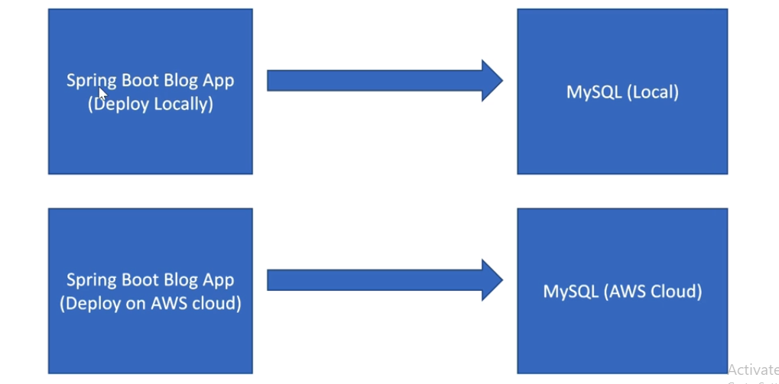

**Important AWS Services every java developer should be aware of:**

1. **Amazon EC2 -** Amazon Elastic Compute Cloud (EC2) is a web service that provides resizable computing capacity in the cloud. It allows users to rent virtual machines (VMs), known as instances, which can be used to run a variety of different operating systems and applications. With EC2, users can easily scale their computing resources up or down as needed, paying only for the resources they actually use. This makes it an ideal service for applications that have varying compute needs, such as web servers, batch processing, and big data processing. EC2 also provides a variety of different instance types, each optimized for different types of workloads, such as compute-optimized, memory-optimized, and storage-optimized instances. Additionally, EC2 also provides features such as load balancing, auto-scaling, and virtual private cloud (VPC) to give users more control and security over their instances
2. **AWS Elastic Beanstalk -**

Amazon Elastic Beanstalk is a fully managed service offered by AWS that makes it easy to deploy, run, and scale web applications and services. It supports several programming languages including Java, .NET, PHP, Node.js, Python, Ruby, and Go. Elastic Beanstalk handles the provisioning of the infrastructure resources, load balancing, and automatic scaling, allowing developers to focus on writing code for their application. The service also includes monitoring and logging features, so developers can easily track the performance and troubleshoot issues.

Elastic Beanstalk provides a simple, unified user interface to deploy and manage web applications, as well as a command-line interface and APIs for more advanced users. It integrates with other AWS services such as Amazon RDS, Amazon S3, Amazon SNS, and AWS Elasticache. Elastic Beanstalk also provides a feature called "platform versions" that allows developers to choose a specific version of the language runtime, web server, and other software components to use with their application.

1. **AMAZON RDS –**

Amazon Relational Database Service (RDS) is a web service that makes it easy to set up, operate, and scale a relational database in the cloud. RDS supports several popular database engines including MySQL, PostgreSQL, Oracle, Microsoft SQL Server, and Amazon Aurora.

RDS automates many of the time-consuming tasks typically associated with managing a relational database, such as provisioning, patching, backup, and recovery. It also provides features such as automatic failover, read replicas, and a point-in-time restore, which help to improve the availability and durability of the database. In addition, RDS allows users to easily scale the resources allocated to a database up or down as needed, and it also offers a variety of different instance types optimized for different types of workloads.

RDS also provides a feature called "Multi-AZ Deployments" that allows the user to create a primary DB instance and synchronously replicate the data to a standby instance in a different availability zone (AZ) for failover capabilities. This provides an automatic failover to the standby instance in the event of a planned or unplanned outage of the primary instance.

1. **S3 Service -** Amazon S3 (Simple Storage Service) is a cloud-based object storage service offered by Amazon Web Services (AWS). It allows users to store and retrieve any amount of data, at any time, from anywhere on the internet. S3 provides a simple web services interface that can be used to store and retrieve any amount of data, at any time, from anywhere on the web. It is designed for storing and retrieving large amounts of data, such as photos, videos, and backups. S3 is widely used for a variety of applications including, cloud storage, backup and archiving, big data analytics, disaster recovery, and more.
2. **Amazon Route 53 –**

Amazon Route 53 is a highly available and scalable Domain Name System (DNS) web service offered by AWS. It translates human-friendly domain names, such as [www.example.com](http://www.example.com/), into the IP addresses, such as 192.0.2.1, that computers use to identify each other on the internet. Route 53 is designed to give developers and businesses a reliable and cost-effective way to route end users to internet applications.

Route 53 provides a variety of different routing types, such as simple routing, which routes traffic to a single resource, such as a web server, and complex routing, which allows you to route traffic based on factors such as the geographic location of your users, the health of your resources, and the routing policies that you specify.

Route 53 also provides a feature called "Health Check", that allows the user to monitor the health of their resources, such as web servers, and route traffic to healthy resources. It also integrates with other AWS services such as Amazon CloudFront, Elastic Load Balancing, and AWS Elastic Beanstalk.

It also provides a feature called "Traffic Flow" that allows the user to create a visual representation of their routing policies and test how the traffic will be routed before it's updated.

**Using Profiles In Spring Boot Application**

**Step 1: Create Following Properties file:**

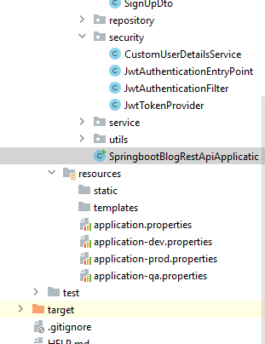

**application.properties file content:**

*#spring.datasource.url = jdbc:mysql://localhost:3306/myblog  
#spring.datasource.username = root  
#spring.datasource.password = test  
  
# hibernate properties  
#spring.jpa.properties.hibernate.dialect = org.hibernate.dialect.MySQL5InnoDBDialect  
  
# Hibernate ddl auto (create, create-drop, validate, update)  
#spring.jpa.hibernate.ddl-auto = update  
  
  
# App Properties*app.jwt-secret= JWTSecretKey  
app.jwt-expiration-milliseconds = 604800000  
  
spring.profiles.active=prod

**application-dev.properties content:**

spring.datasource.url = jdbc:mysql://localhost:3306/myblog  
spring.datasource.username = root  
spring.datasource.password = test  
  
*# hibernate properties*spring.jpa.properties.hibernate.dialect = org.hibernate.dialect.MySQL5InnoDBDialect  
  
*# Hibernate ddl auto (create, create-drop, validate, update)*spring.jpa.hibernate.ddl-auto = update

**application-qa.properties content:**

spring.datasource.url = jdbc:mysql://localhost:3306/myblog  
spring.datasource.username = root  
spring.datasource.password = test  
  
*# hibernate properties*spring.jpa.properties.hibernate.dialect = org.hibernate.dialect.MySQL5InnoDBDialect  
  
*# Hibernate ddl auto (create, create-drop, validate, update)*spring.jpa.hibernate.ddl-auto = update

**application-prod.properties content:**

spring.datasource.url = jdbc:mysql://localhost:3306/myblog  
spring.datasource.username = root  
spring.datasource.password = test  
  
*# hibernate properties*spring.jpa.properties.hibernate.dialect = org.hibernate.dialect.MySQL5InnoDBDialect  
  
*# Hibernate ddl auto (create, create-drop, validate, update)*spring.jpa.hibernate.ddl-auto = update

**Step 2: Create default (Meta Data) in tables**

**Manually Enter Data into Roles Table Using Command Line Runner**

package com.springboot.blog;  
  
import com.springboot.blog.entity.Role;  
import com.springboot.blog.repository.RoleRepository;  
import org.modelmapper.ModelMapper;  
import org.springframework.beans.factory.annotation.Autowired;  
import org.springframework.boot.CommandLineRunner;  
import org.springframework.boot.SpringApplication;  
import org.springframework.boot.autoconfigure.SpringBootApplication;  
import org.springframework.context.annotation.Bean;  
  
@SpringBootApplication  
public class SpringbootBlogRestApiApplication implements CommandLineRunner {  
  
 @Autowired  
 private RoleRepository roleRepository;  
  
 @Bean  
 public ModelMapper modelMapper(){  
 return new ModelMapper();  
 }  
  
 public static void main(String[] args) {  
 SpringApplication.*run*(SpringbootBlogRestApiApplication.class, args);  
 }  
  
 @Override  
 public void run(String... args) throws Exception {  
 Role adminRole = new Role();  
 adminRole.setName("ROLE_ADMIN");  
 roleRepository.save(adminRole);  
  
 Role userRole = new Role();  
 userRole.setName("ROLE_USER");  
 roleRepository.save(userRole);  
 }  
  
}

**Step 3: Create Amazon AWS Account**

**Link:** [**https://portal.aws.amazon.com/billing/signup?refid=14a4002d-4936-4343-8211-b5a150ca592b&redirect_url=https%3A%2F%2Faws.amazon.com%2Fregistration-confirmation#/start/email**](https://portal.aws.amazon.com/billing/signup?refid=14a4002d-4936-4343-8211-b5a150ca592b&redirect_url=https%3A%2F%2Faws.amazon.com%2Fregistration-confirmation#/start/email)

**Creating Environment and setting up database in AWS**

**Step 1: Search for RDS Service:**

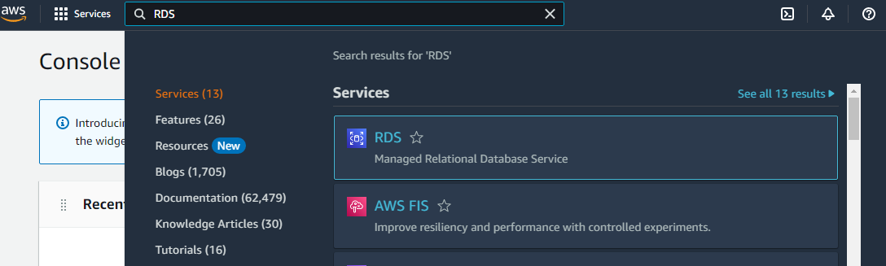

**And Click on Dashboard**

**Step 2: Click on create database**

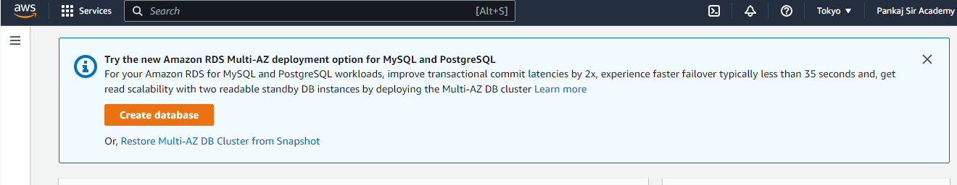

**Step 3: Select MySQL Database:**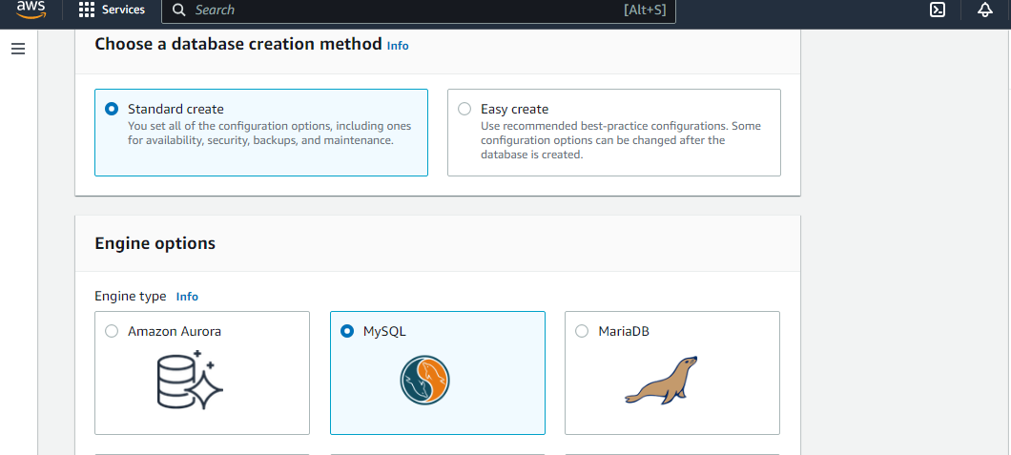

**Step 4: Select Version and Free Tier**

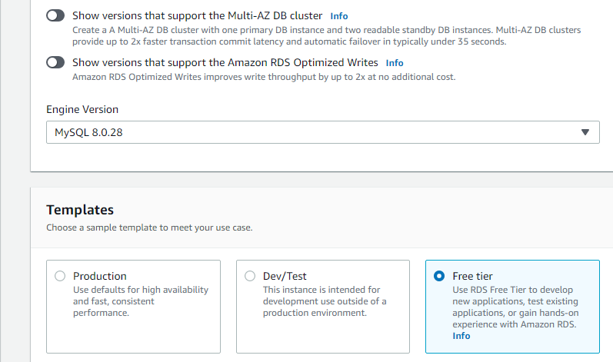

**Step 5: Give Database Instance Name, Username(root) & Password(Mysql123$):**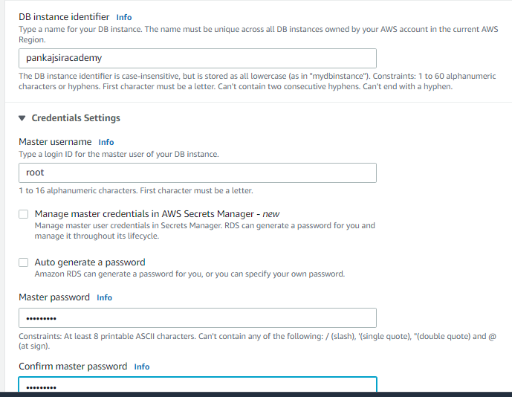

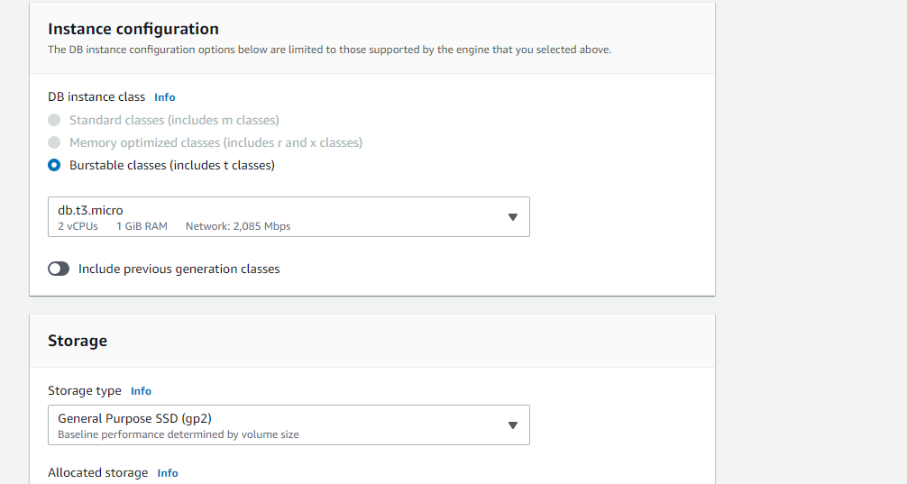

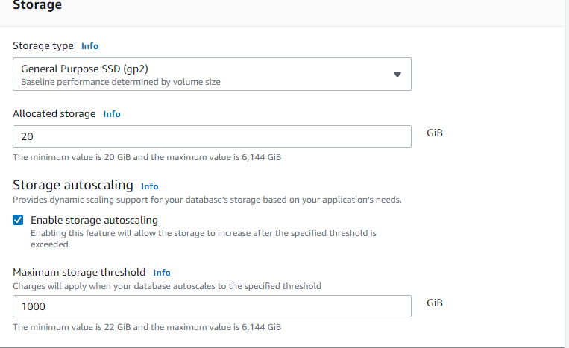

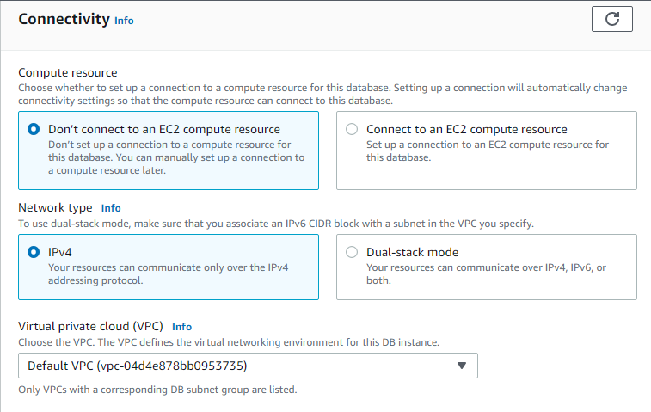

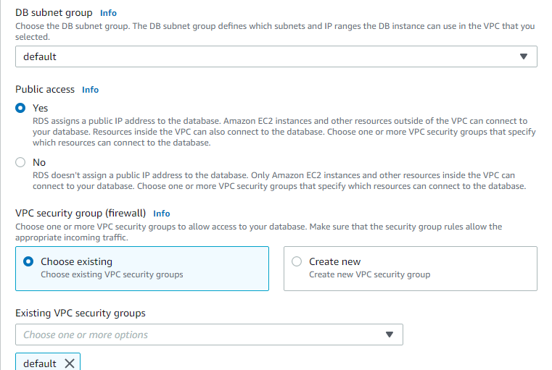

**Keep all further things default…. Click on create database**

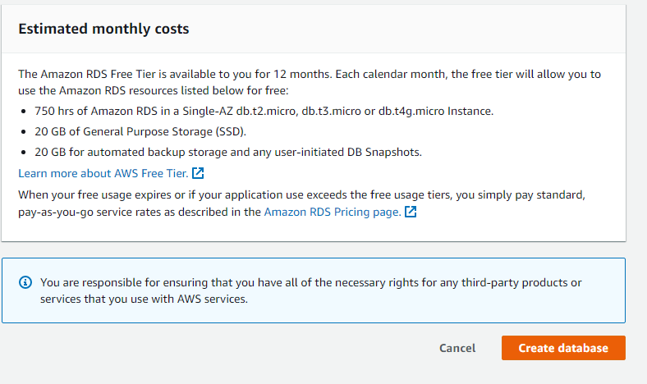

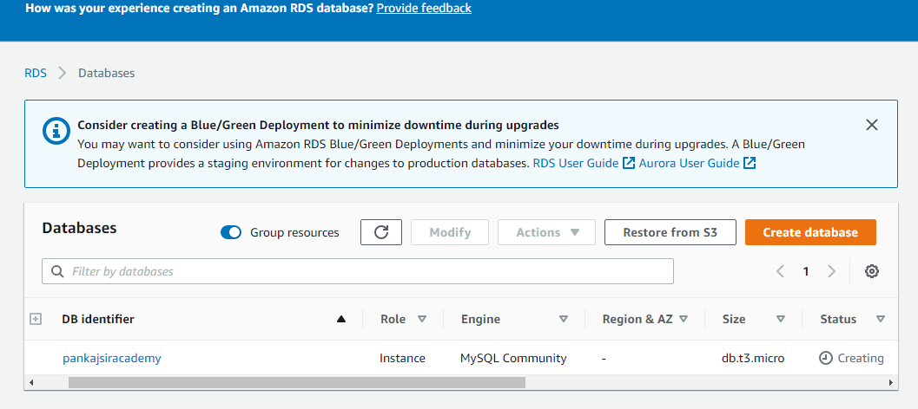

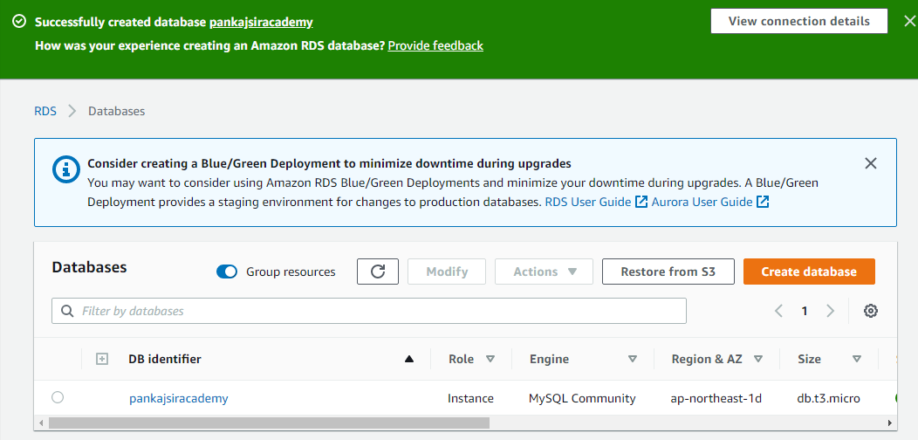

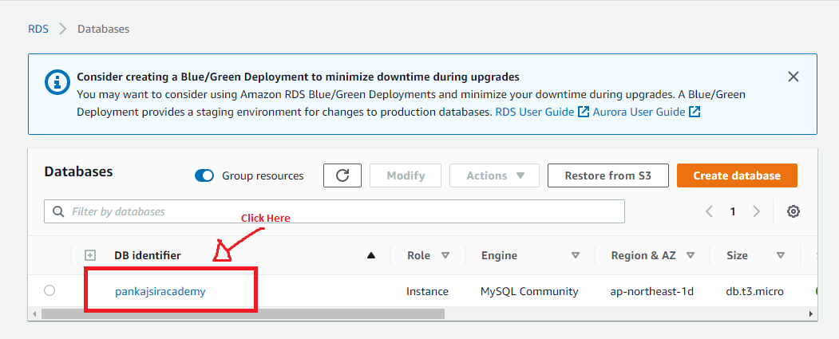

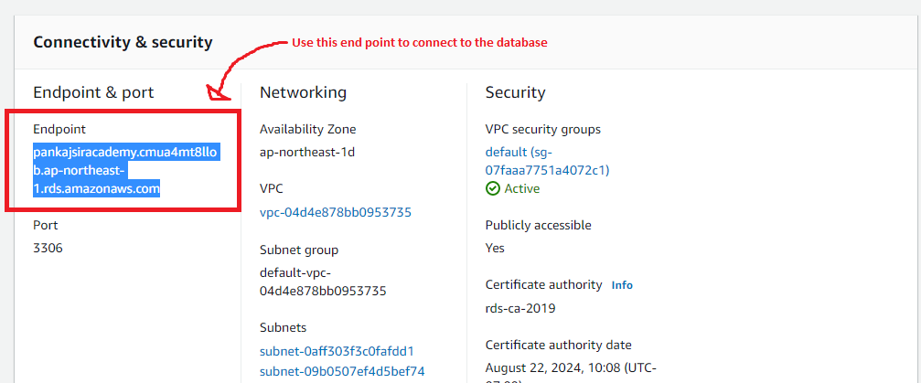

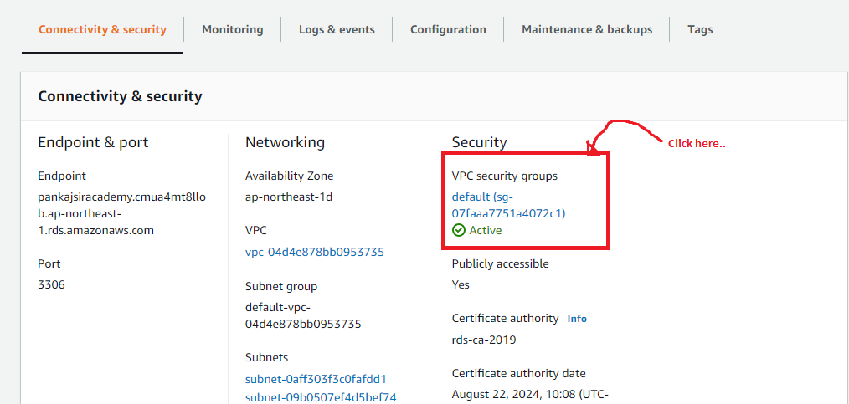

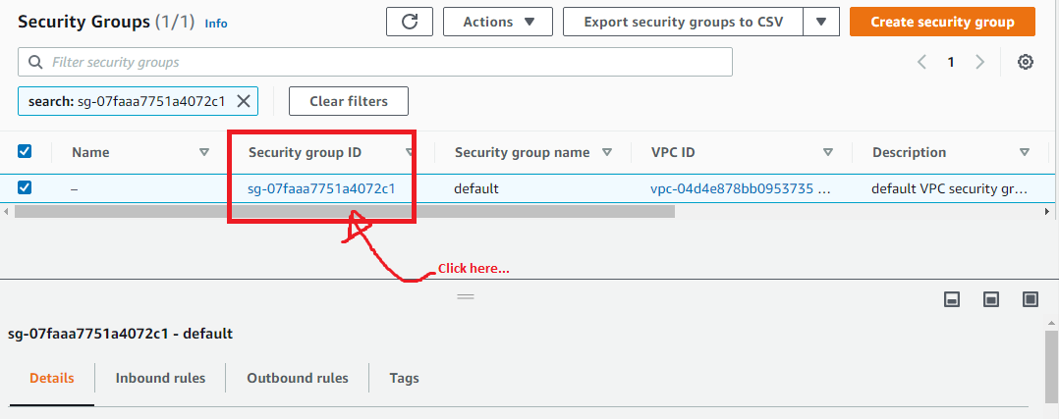

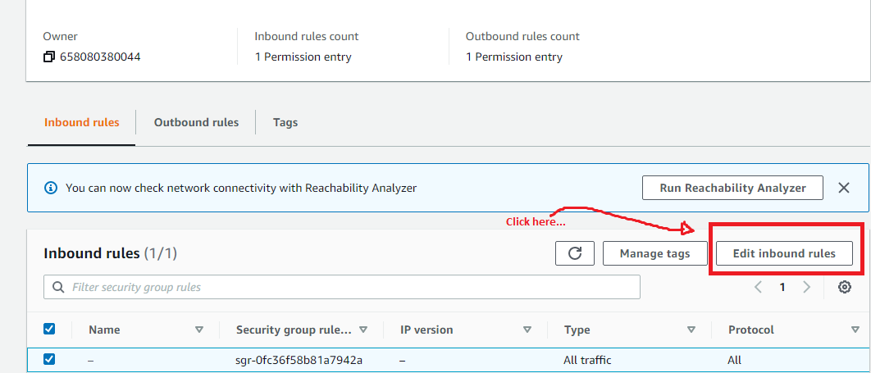

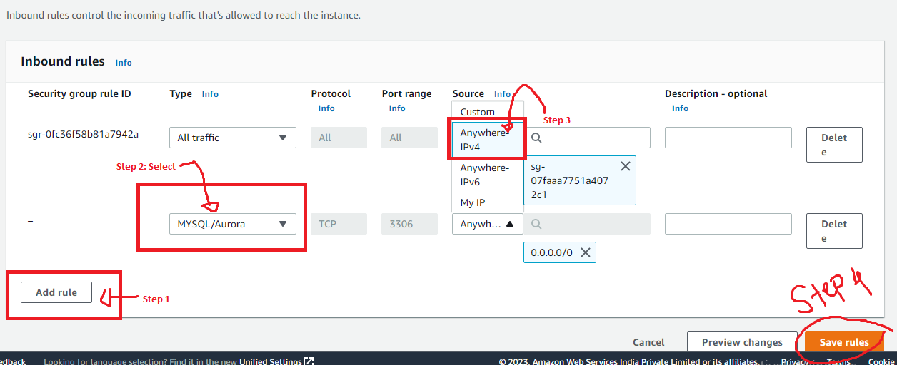

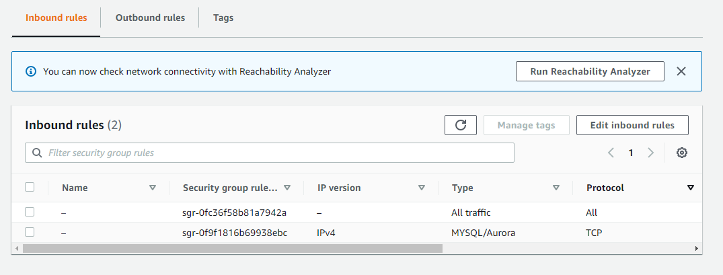

**Go to DB Instance Now…**

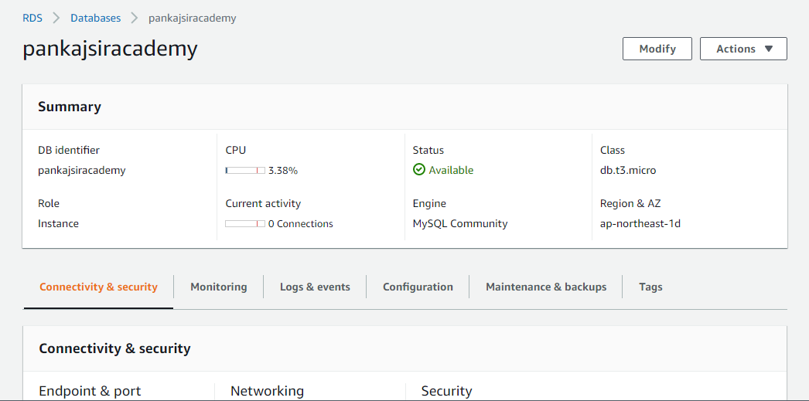

**Connecting AWS MySQL Database to MySQL Workbench**

**Step 1:**

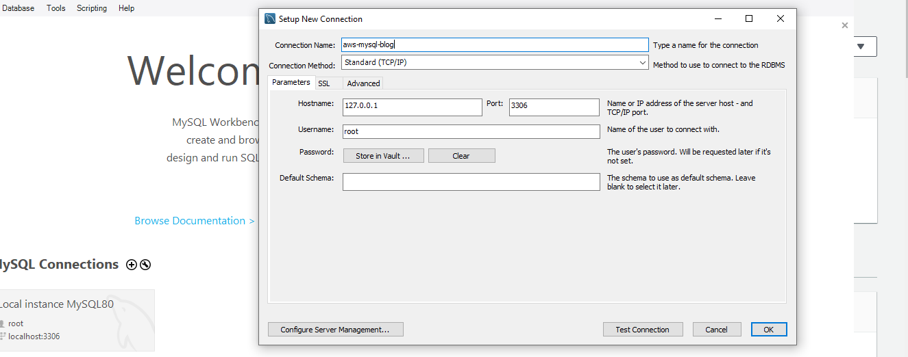

**Step 2: Go to AWS:**

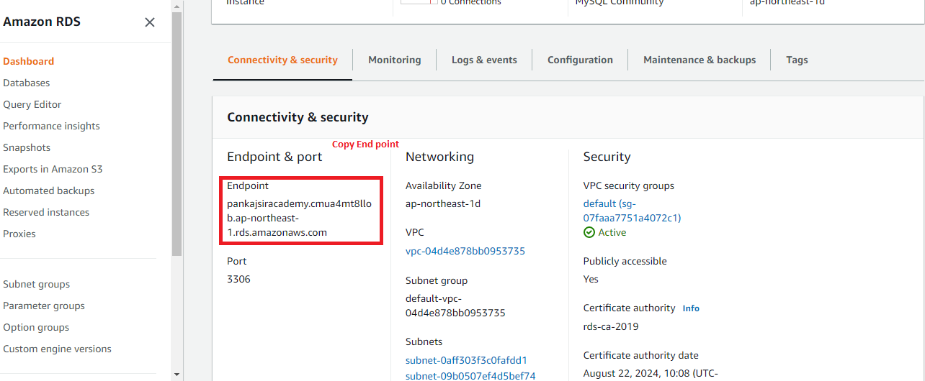

**Step 3: Update Localhostname**

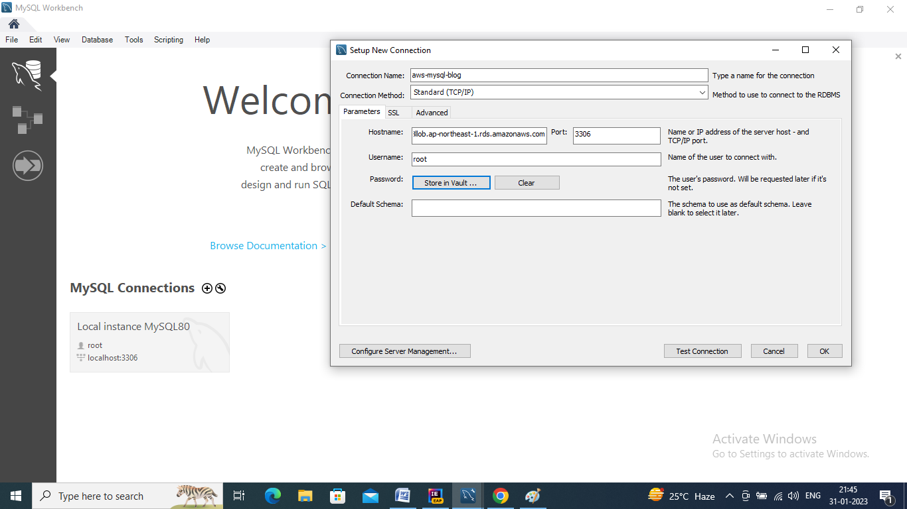

**Step 4: Give aws password by clicking on store in vault**

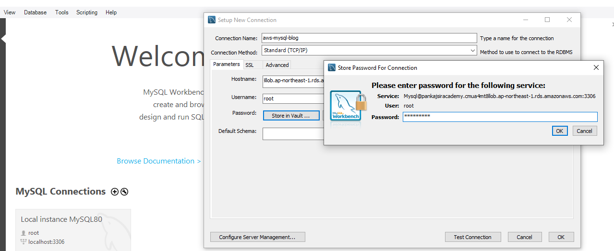

**Step 5: Click okay and test the connection**

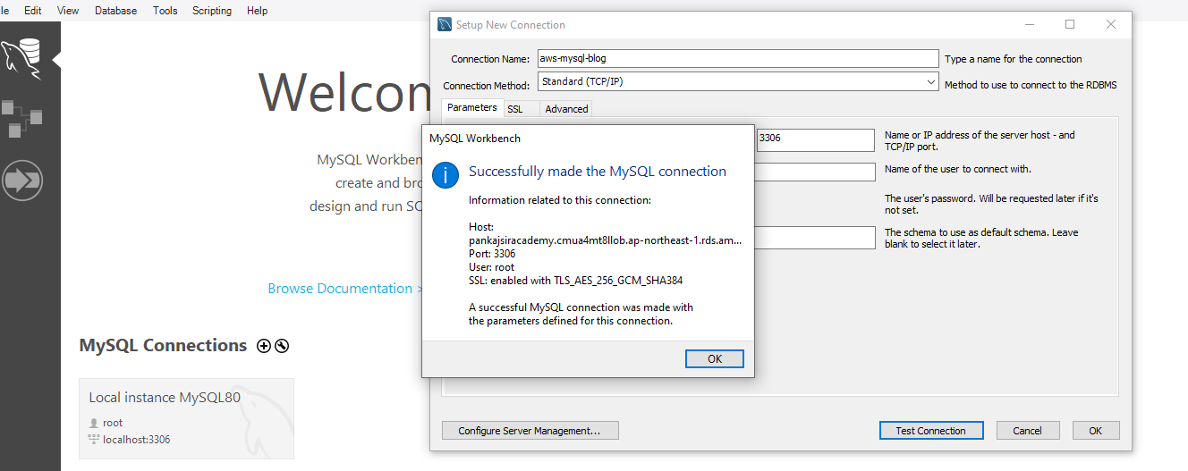

**Step 6: Click on ok**

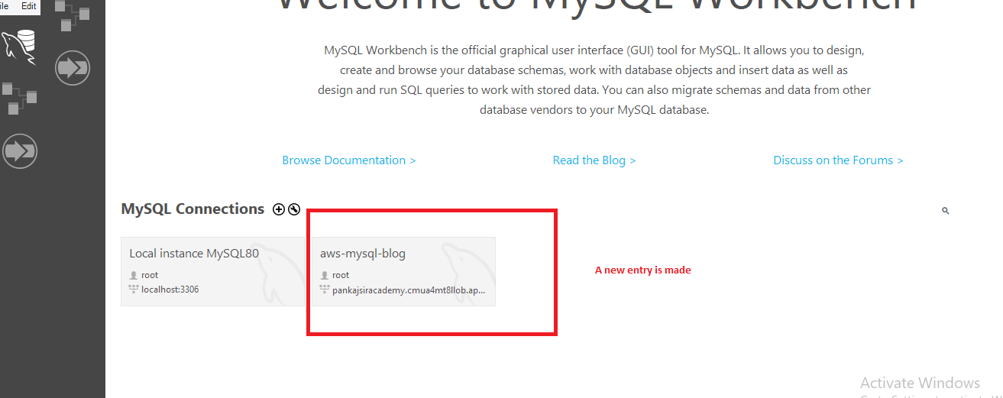

**Step 7: Create Database in aws throughmysql workbench**

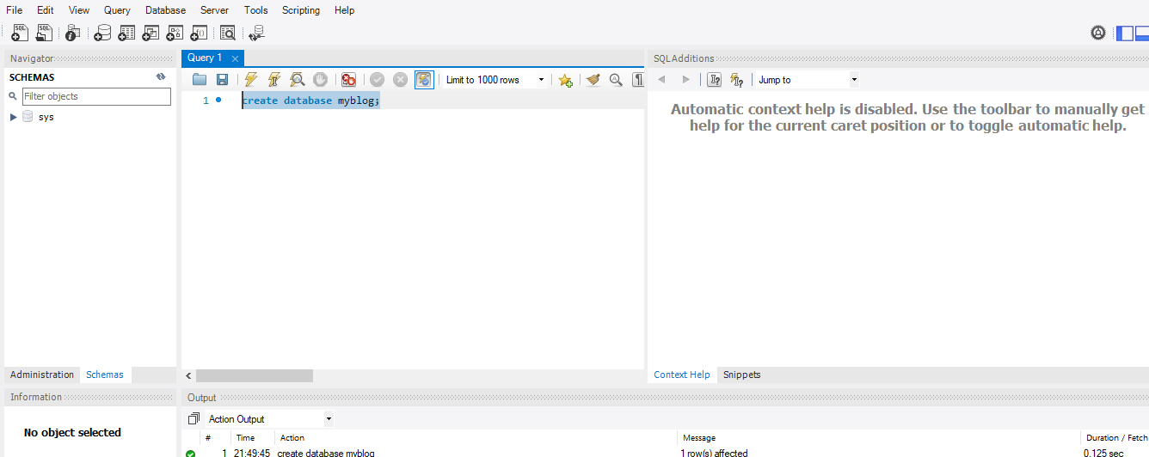

**Package Spring Boot App as jar file**

**Step 1: Copy endpoint from AWS**

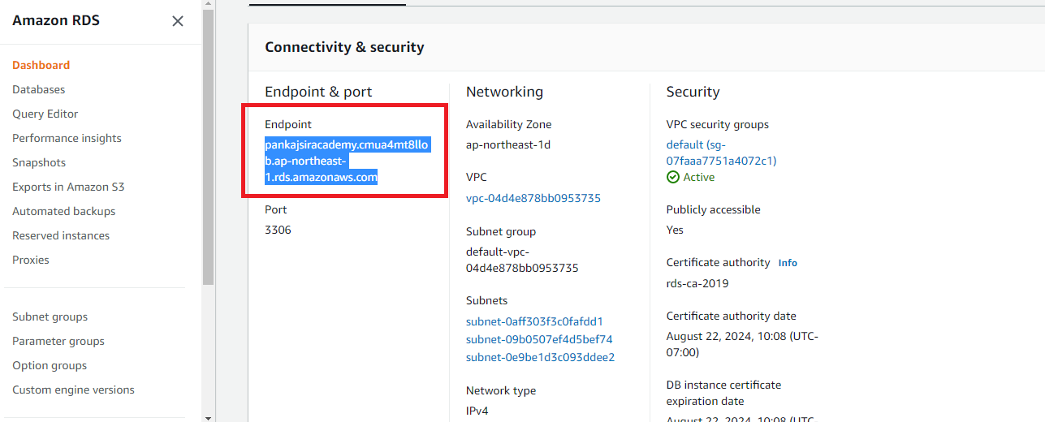

**Step 2: Update application-prod.properties file:**

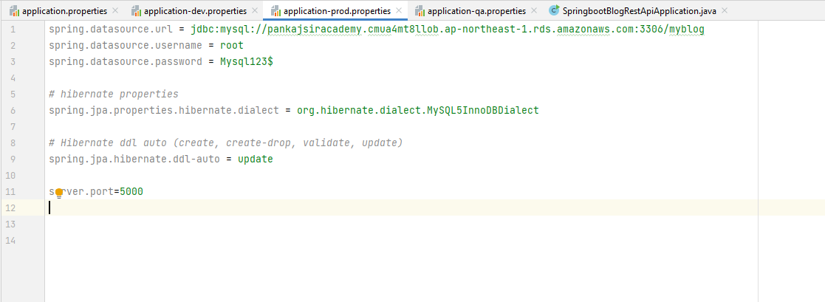

**Step 3: Perform maven clean & Install**

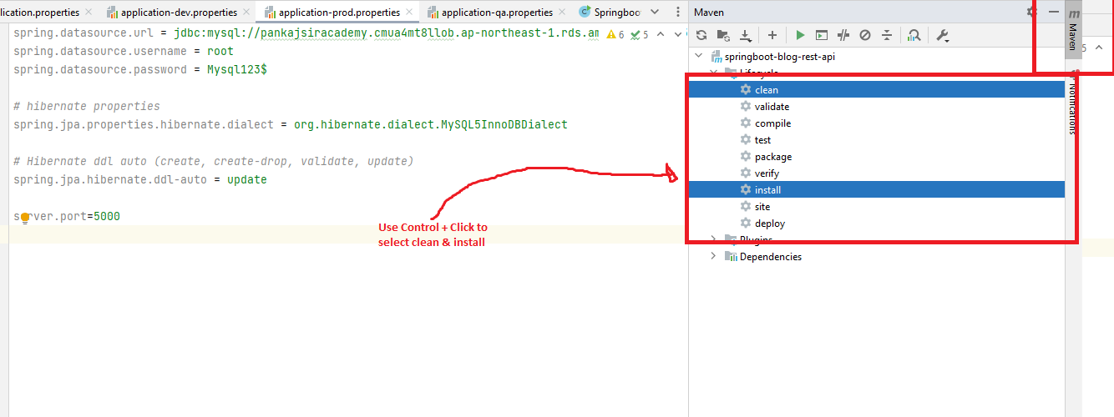

**Step 4: In run you should see the following message:**

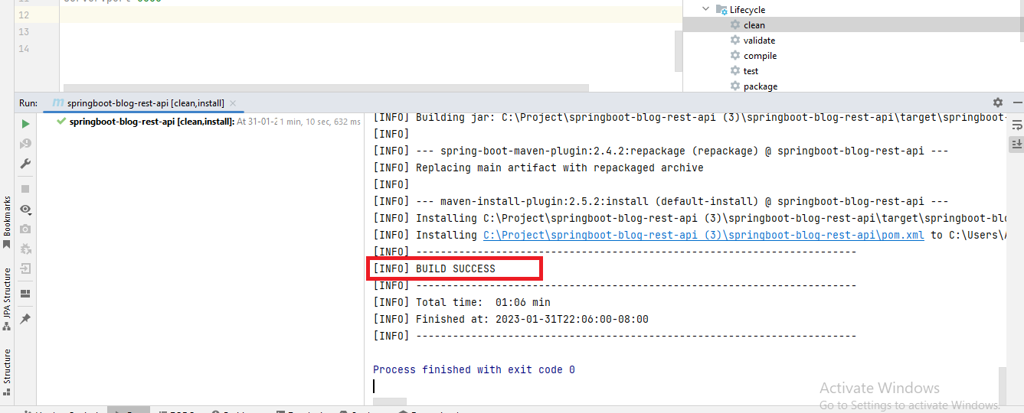

**Step 5: See the jar files in intelliJ generated below:**

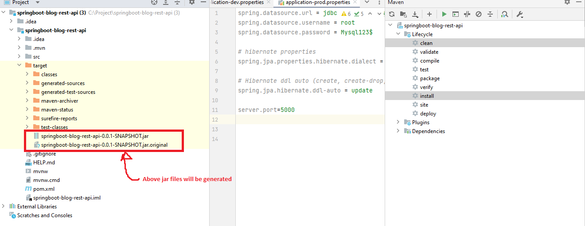

**Deploy Spring Boot JAR file on AWS Cloud using Elastic BeanStalk**

**Step 1: Go Elastic BeanStalk in AWS Console:**

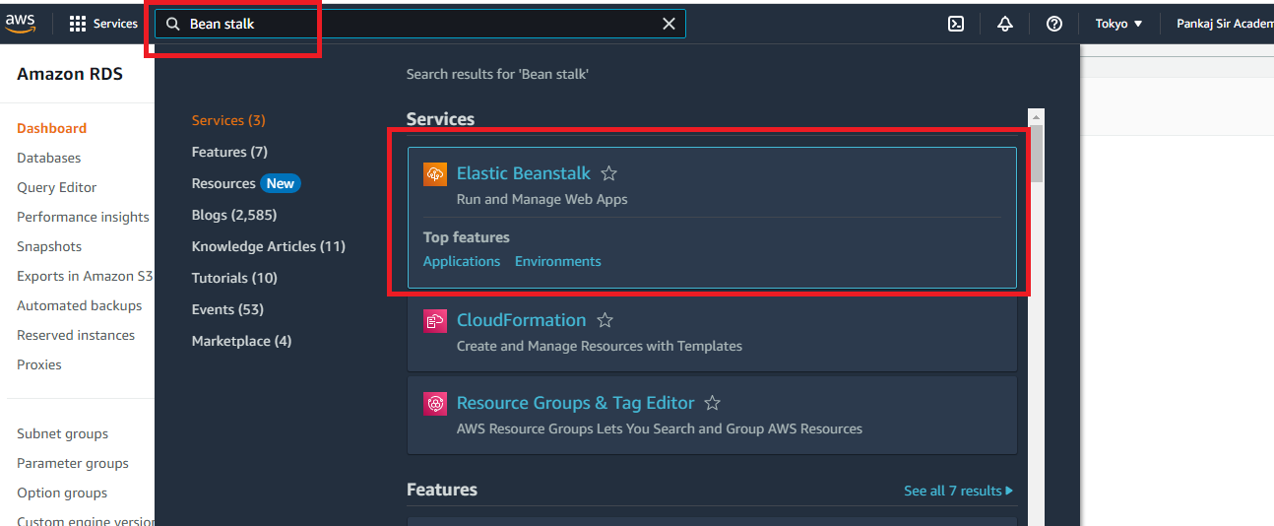

**Step 2: Click on create Application:**

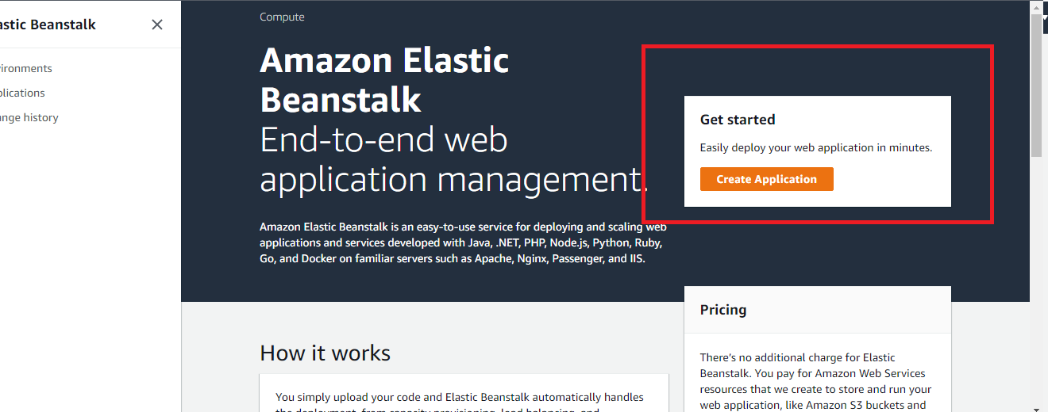

**Step 3:**

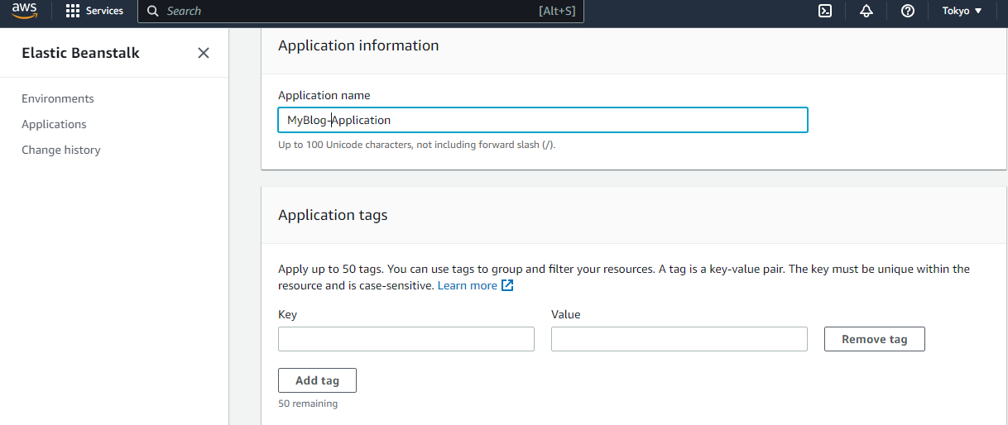

**Step 4:**

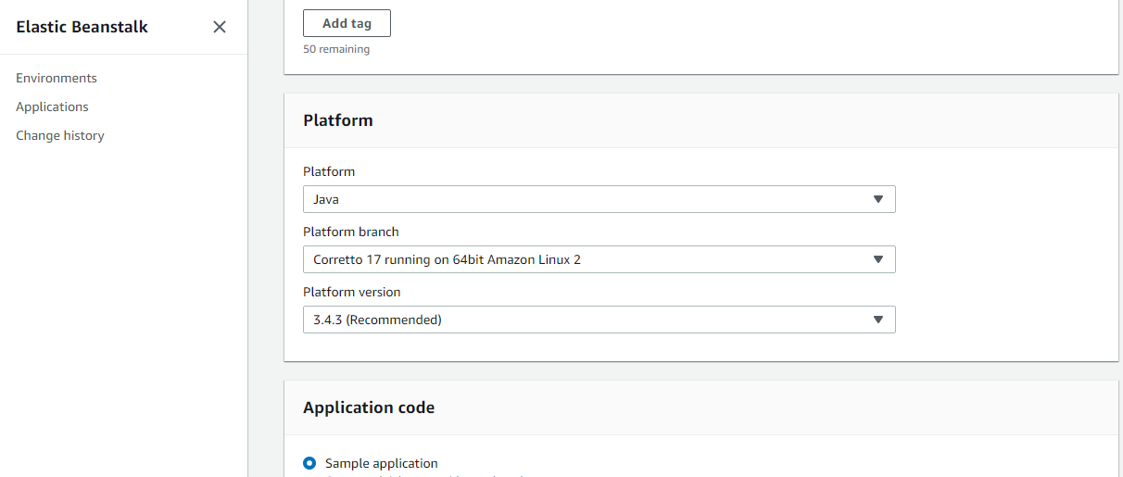

**Step 5:**

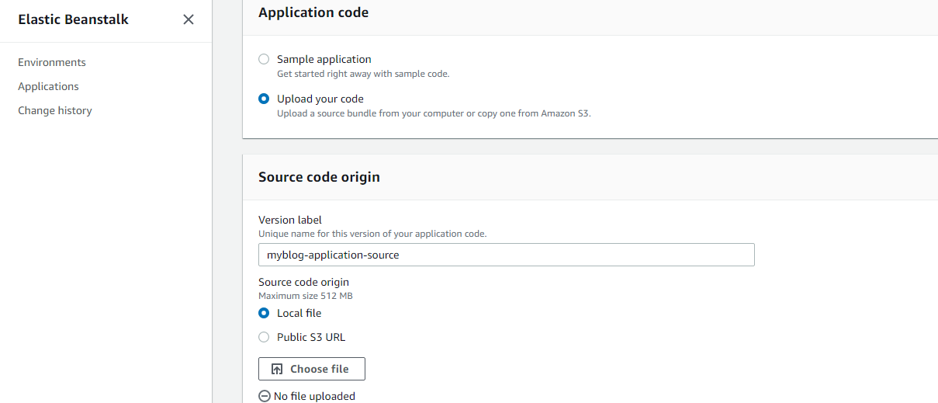

**Step 6:**

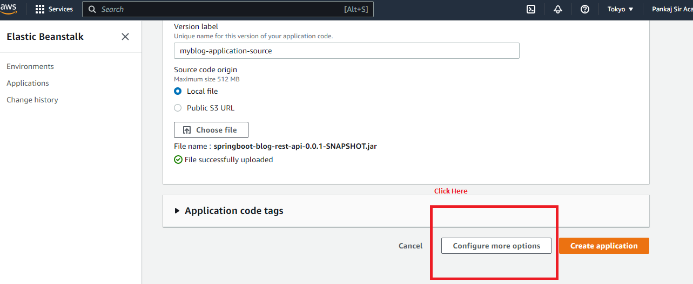

**Step 7:**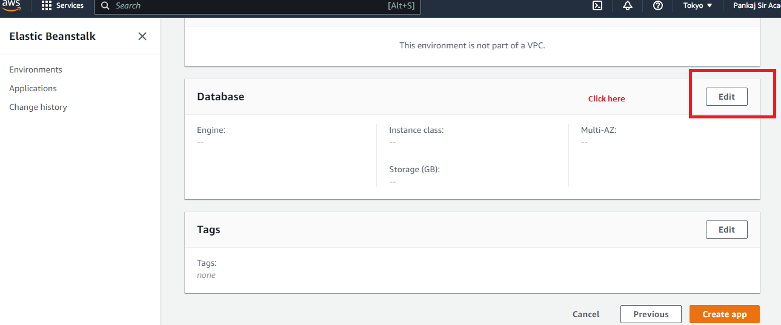

**Step 8:**

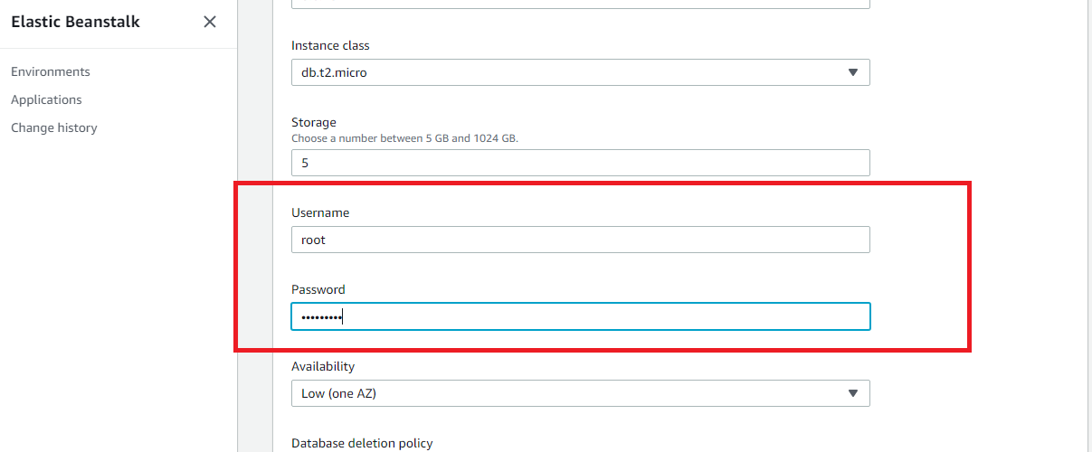

**Step 9: Click on save**

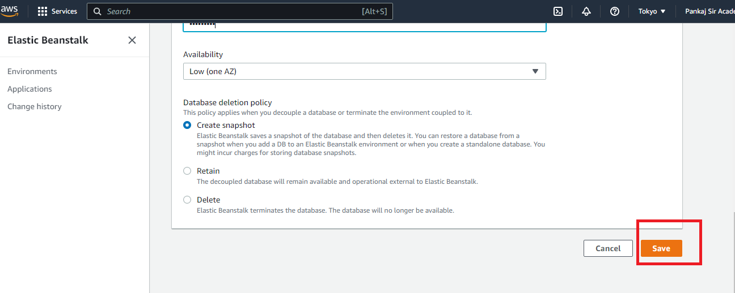

**Step 10:**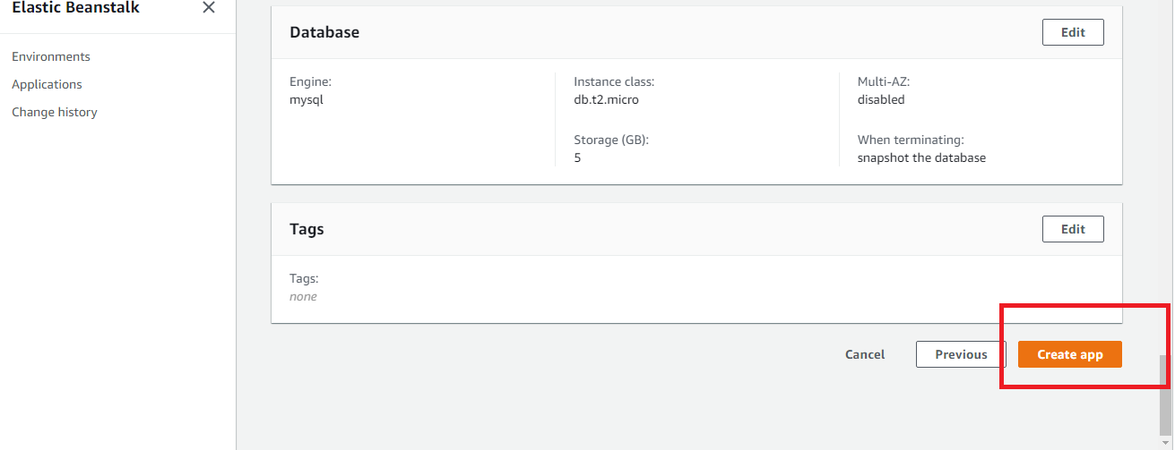

**Step 11:**

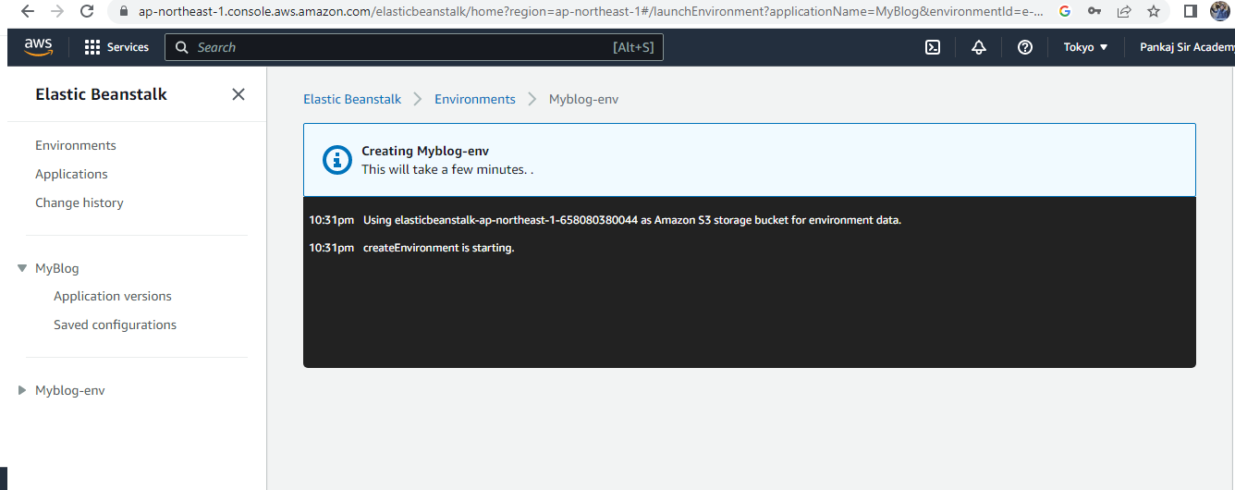

**Step 12:**